Theoretical Manual
This document outline is based on the IEEE Standard 1058.1-1987 for Software Project Management Plans.
This is the controlling document for managing a software project, and it defines the technical and managerial processes necessary to deliver the project requirements.
The paragraphs written in the “Comment” style are for the benefit of the person writing the document and should be removed before the document is finalized.
For
QConBridge II
A Member of the Alternate Route Project
Version 1.0
August 10, 2000
Richard Brice, PE
WSDOT
Richard Pickings, PE
BridgeSight Software
0000.doc
Revision Chart
This chart contains a history of this document’s revisions. The entries below are provided solely for purposes of illustration. Entries should be deleted until the revision they refer to has actually been created.
The document itself should be stored in revision control, and a brief description of each version should be entered in the revision control system. That brief description can be repeated in this section. Revisions do not need to be described elsewhere in the document except inasmuch as they explain the development plan itself.

Version | Primary Author(s) | Description of Version | Date Completed
1.0 | RAB, RDP | Original Document | 8/10/2000

Contents
New paragraphs formatted as Heading 1, Heading 2, and Heading 3 will be added to the table automatically. To update this table of contents in Microsoft Word, put the cursor anywhere in the table and press F9. If you want the table to be easy to maintain, do not change it manually.
1. Introduction 7
1.1 Overview 7
1.2 Document Organization 7
2. Material Properties 8
2.1 Concrete 8
2.2 Steel 8
3. Flexible Span Lengths 9
3.1 Skew Effects 9
3.2 Horizontal Curvature Effects 9
3.2.1 Left Curves 10
3.2.2 Right Curves 10
3.3 Effects of Connections 10
4. Section Properties 11
4.1 General 11
4.1.1 Superstructure Elements 11
4.1.2 Substructure Elements 11
4.2 Concrete Slab on Beam Bridges 11
4.2.1 Section Properties for Non-composite Beams 11
4.2.2 Section Properties for Composite Beams 12
4.2.2.1 Effective Slab Area 12
4.3 Cap Beams 15
4.4 Columns 15
5. Live Load Distribution Factors 16
5.1 Cross Section Types 16
5.2 Method of Calculation 16
5.3 Span Length used in Calcuations 16
5.4 Skew Correction Factors 16
5.5 Distribution Factors for Reactions 17
5.6 Distribution Factors for Deflection 17
5.7 Distribution Factors for Rotations 17
5.8 Distribution of Pedestrian Live Load 17
6. Longitudinal Bridge Analysis Models 18
6.1 Model Topology 18
6.1.1 Superstructure Elements 18
6.1.2 Substructure Elements 19
6.1.2.1 Abutments 19
6.1.2.2 Piers 20
6.1.3 Modeling Connections 23
6.1.3.1 Abutment Connection 23
6.1.3.2 Continuous Pier Connection 25
6.1.3.3 Integral Pier Connection 26
6.1.3.4 Simple Support Pier Connection 27
6.2 Analysis Stages 28
6.2.1 Staged Analysis Constraints 28
6.3 Loads 29
6.3.1 Dead Load 29
6.3.1.1 Load in Main Span 29
6.3.1.2 Loads in Connection Region 38
6.3.2 Live Load 50
6.3.2.1 Vehicular Live Load 50
6.3.2.2 Pedestrian Live Load 50
6.3.3 Temperature Load 50
6.3.4 Support Settlement Load 50
6.3.5 Slab Shrinkage 51
6.4 Special Analysis Considerations 51
6.4.1 Dead Load Deflections 52
6.4.2 Live Load Deflections 52
6.4.2.1 For Evalution of Deflection Criteria 52
6.4.2.2 For HL93 Live Load 53
6.4.3 Calculation of Rotations 53
6.5 Analysis Results 53
6.5.1 The Basic Process 53
6.5.1.1 Analysis and Results Processing 55
6.5.1.2 Enveloping Simple/Continuous Results 56
6.5.1.3 Load Cases and Limit States involving Live Load 57
6.5.2 Computing Analysis Results 59
6.5.2.2 Load Case Dependencies 60
6.5.2.3 Distribution of Live Load to Girder Lines 61
6.5.2.4 Deflections 61
6.5.3 Reactions 62
6.5.3.1 Limit State Combinations for Reactions 62
6.5.3.2 Zero Height Abutments and Piers 62
6.5.3.3 Fixed Height Abutments 62
6.5.3.4 Fixed Height Piers 63
6.5.4 Deflections for evaluation LRFD 2.5.2.6.2 63
6.5.5 Pedestrian Only Bridges 63
7. Transverse Bridge Analysis Models 64
7.1 Model Topology 64
7.1.1 Cap Beam Modeling 64
7.1.2 2D Zero-Height Piers 65
7.1.3 3D Zero-Height Piers 65
7.1.4 2D Fixed Height Piers 65
7.1.5 3D Fixed Height Piers 65
7.1.6 Full Product Model Piers 66
7.2 Loads 66
7.2.1 Adjustments for Skew 66
7.2.2 Pier Loads 67
7.2.2.1 Pier Self Weight 67
7.2.2.2 Other Loads 67
7.2.3 Superstructure Loads 67
7.2.3.1 Girder Self Weight 67
7.2.3.2 Slab Self Weight 67
7.2.3.3 Intermediate Diaphragms 67
7.2.3.4 End Diaphragms 67
7.2.3.5 Traffic Barrier 68
7.2.3.6 Median Barrier 68
7.2.3.7 Overlay 68
7.2.3.8 Sidewalk 68
7.2.3.9 Live Loads 68
7.3 Analysis Results 77
7.3.1 The Basic Process 77
7.3.2 TBAM Results 79
7.3.3 Total Pier Results (Combining LBAM Results) 79

List of Figures
New figures that are given captions using the Caption paragraph style will be added to the table automatically. To update this table of contents in Microsoft Word, put the cursor anywhere in the table and press F9. If you want the table to be easy to maintain, do not change it manually.
This section can be deleted if the document contains no figures or if otherwise desired.
Figure 1 Skew Effects for computing Flexible Span Length 9
Figure 2 Connection Effects for computing Flexible Span Length 10
Figure 3 Effective Span Lengths for computing Effective Flange Width 13
Figure 4 Procedure for computing Effective Flange Width 14
Figure 5 Effective Slab Depth 14
Table 1 Skew Angle for computing Skew Correction Factors 17
Figure 6 Model Geometry for Slab on Girder Bridges 18
Figure 7 BAM Detail for Zero-Height Idealized Abutments 19
Figure 8 BAM Detail for Fixed-Height Idealized Abutments 20
Figure 9 LBAM Model of Zero-Height Idealized Piers 21
Figure 10 LBAM Model of Fixed-Height Idealized Piers 21
Figure 11 LBAM Modeling of Full Product Model Piers 22
Figure 12 Column Height when Bottom Elevation is specified 23
Figure 13 Abutment Connection on a Zero Height Abutment 24
Figure 14 Abutment Connection on a Fixed Height Abutment 25
Figure 15 Continuous Pier Connection on a Zero Height Idealized Pier 25
Figure 16 Continuous Pier Connection on a Fixed Height Idealized Pier 26
Figure 17 Integral Pier Connection on a Zero Height Idealized Pier 26
Figure 18 Integral Pier Connection on a Fixed Height Idealized Pier 27
Figure 19 Simple Support Pier Connection on a Zero Height Idealized Pier 27
Figure 20 Simple Support Pier Connection on a Fixed Height Idealized Pier 28
Figure 21 Modeling of Main Span Loads 29
Figure 22 Tributary Slab Width 31
Figure 23 Tributary Slab Width for an Exterior Girder 31
Figure 24 Slab Pad (Haunch) Load 33
Figure 25 Abutment Connection Loads 38
Figure 26 Simple Support Pier Connection Loads 44
Figure 27 Slab Shrinkage Moments 51
Figure 28 Section Geometry for Slab Shrinkage Moments 51
Figure 29 Basic LBAM Analysis Process 54
Figure 30 Analysis and Results Processing 55
Figure 31 Analysis and Results Processing for Simple/Continuous Envelopes 57
Figure 32 Maximum Limit States with Live Load 58
Figure 33 Minimum Limit States with Live Load 59
Figure 34 Load Case Dependencies 60
Figure 35 Basis for computing Limit State Deflections 62
Figure 36 Structural Modeling of Cap Beam 64
Figure 37 TBAM for a 3D Zero Height Idealized Pier 65
Figure 38 Analysis Modeling of Fixed Height 3D Piers 65
Figure 39 TBAM for Multicolumn and Hammerhead Piers 66
Figure 40 Representation of Vehicular Live Load Reactions in TBAM's 69
Figure 41 Lane Configurations 70
Figure 42 Design Lane Configuration with one sidewalk 71
Figure 43 Design Lane Configuration with two sidewalks 71
Figure 44 Design Lane Configuration for TBAM's 72
Figure 45 Permutations of Loaded Design Lanes for a 3 Lane Structure 73
Figure 46 Permutations of Loaded Design Lanes for a 3 Lane Structure with a Sidewalk 74
Figure 47 Permutations of Loaded Design Lanes for a 3 Lane Structure with two Sidewalks 75
Figure 48 Rigid Links Load Transfer Model 76
Figure 49 Drop-Through Load Transfer Model 77
Figure 50 Basic TBAM Analysis Process 78
Figure 51 LBAM Reactions Transformed to plane of TBAM 79

Introduction
This section should describe the purpose and background of the project and the organization of this document. No text is necessary between the heading above and the heading below unless otherwise desired.

Overview
Give a short summary of the project objectives.
The purpose of this document is to provide a detailed description of how QConBridge II performs its analytical work.

Document Organization
List all of the major sections of the document, symbols, etc.
This document is broken into seven main sections: Section 1 - Introduction explains the purpose of this document. Section 2 - Material Properties details how QConBridge II computes material properties. Section 3 - Flexible Span Lengths details how the various geometric parameters effect the flexible span length used in several of the analyzes. Section 4 - Section Properties describes how QConBridge II computes section properties for the supported product models. Section 5 - Live Load Distribution Factors details how distribution factors are calculated and how the ambiguous portions of the LRFD specification are dealt with. Section 6 - Longitudinal Bridge Analysis Models describe in detail how LBAMs are created, loaded, analyzed, and how the raw results are post-processed. Section 7 - Transverse Bridge Analysis Models provides in-depth coverage of TBAMs.

Material Properties
Material properties will be determined as described in this section. All materials must have a modulus of elasticity, unit weight/density for weight calculations, unit weight/density for strength calculations, and a coefficient of thermal expansion.

Concrete
Properties for concrete will be as specified in LRFD 5.4.2. The 28 day compressive strength must be between 4ksi and 10ksi (28MPa and 70MPa).
The modulus of elasticity of concrete will be computed in accordance with LRFD 5.4.2.4.
US - For unit weights between 0.090 and 0.155 kip/ft³, E_{c} is computed as 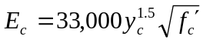. For analyses done in accordance with WSDOT criteria the range of unit weights is 0.090 to 0.160 kip/ft³.
SI - For densities between 1440 and 2500 kg/m³, E_{c} is computed as 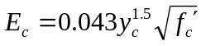. For analyses done in accordance with WSDOT criteria the range of densities is 1440 to 2560 kg/m³.1

Steel
Properties for reinforcing steel will be as specified in LRFD 5.4.3
Properties for structural steel will be as specified in LRFD 6.4.1

Flexible Span Lengths
In product models, the pier-to-pier span length is generally not the same as the flexible span length for a girder line. Skew, horizontal curvature of the roadway, and connection details all factor into the flexible span length. Flexible span lengths are used in analysis models.
The flexible span length of a girder is computed as 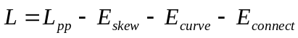, where:
L_{pp} | Pier to pier span length - For curved structures, this may be measured as a chord or a distance along the curve. Built-up steel plate girders are generally curved. Rolled-I beams and Precast Beams are generally straight.
E_{skew} | Effect of skew at start and end of the girder
E_{curve} | Effect of horizontal curve at start and end of girder
E_{connect} | Effect of connections at start and end of girder

Skew Effects
Skew effects occur when the piers at either end of a span are skewed.
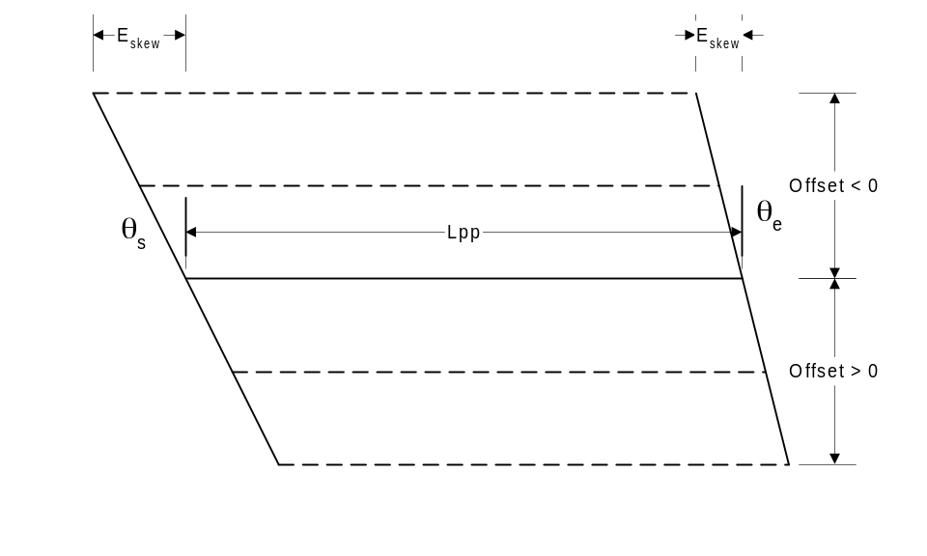
Figure 1 Skew Effects for computing Flexible Span Length
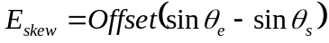

Horizontal Curvature Effects
Horizontal curve effects occur when a bridge is curved in plan. The pier to pier span length is measured long a survey line. Girder lines that are offset from the survey line are either longer or shorter because the radius of the curve defining the girder line (or the end points of the girder line if it is a chord) is larger or smaller.

Left Curves
For curves towards the left, when looking ahead on station, the horizontal curve effect can be computed as 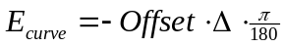.

Right Curves
For curves towards the right, when looking ahead on station, the horizontal curve effect can be computed as 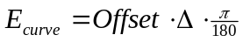.

Effects of Connections
Connections define the location of the point of bearing relative to the centerline of the pier. The flexible span length must be adjusted for the effects of the Girder Bearing Offset defined in Section 3.1.2.5 of the System Design Manual. The Girder Bearing Offset is measured normal to the pier centerline and must be adjusted for skew angle.
The effects of connections can be computed as 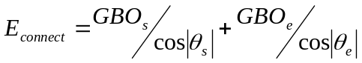
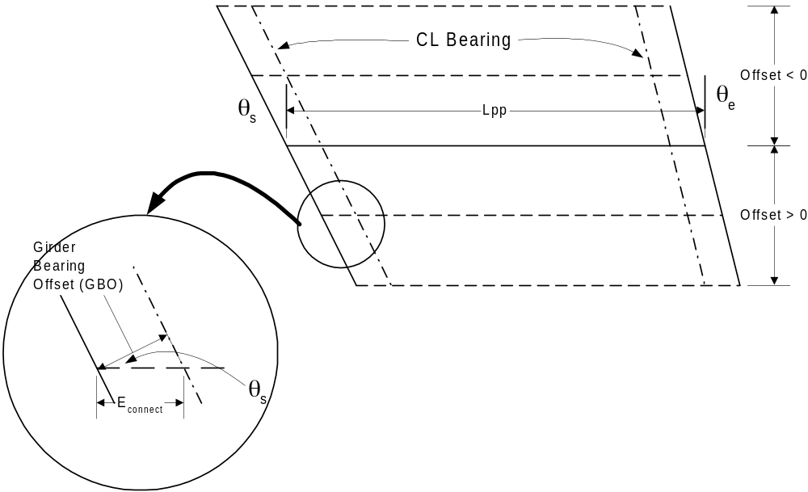
Figure 2 Connection Effects for computing Flexible Span Length

Section Properties
QConBridge II will perform its structural analysis using stiffness methods. In order to perform this analysis, section properties need to be computed.

General
Section properties can be changed at each analysis stage. For Bridge Analysis Model Projects, the user is responsible for computing and inputting section properties. For Product Model Projects, QConBridge II will compute the appropriate section properties for each stage of analysis.
QConBridge II requires cross sectional area and moment of inertias for superstructure and substructure elements

Superstructure Elements
Two sets of section properties are required for every superstructure element: One set is required for computing moments, shears, and reactions,another set is required for computing deflections.
Section properties for deflection are governed by LRFD 2.5.2.6.2 and 4.6.2.6.1. LRFD 2.5.2.6.2 applies to deflections from vehicular live load and states, For composite design, the design cross-section should include the entire width of the roadway and any structurally continuous portions of the railings, sidewalks, and median barriers. LRFD 4.6.2.6.1 applies to deflections from permanent loads in girder line models and states, The calculation of deflections should be based on the full flange width.
In order to compute limit state deflections for a longitudinal bridge analysis model, the live load deflection will have to be scaled to a single girder line. The details of this are described in Sections 5.6 and 6.4.2.

Substructure Elements
Only one set of section properties is needed for substructure elements. Section properties are required for elements that represent the columns and the cap beam.

Concrete Slab on Beam Bridges
The following sections describe how QConBridge II will compute section properties of superstructure elements for generic Slab on Beam Bridges. Section properties are based on gross or transformed cross section dimensions unless stated otherwise.
The slab on beam bridges supported by QConBridge II all have stages where the beams are non-composite and then later made composite with the concrete slab.

Section Properties for Non-composite Beams
Section properties for non-composite beams will be computed using conventional means.

Section Properties for Composite Beams
Composite cross sectional properties will be computed using transformed sections. The effective slab area will be transformed into an equivalent girder section by scaling its properties by 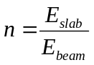.

Effective Slab Area
An effective flange width and an effective slab depth define the effective slab area. For the purposes of computing section properties, the effective slab area is assumed to be directly on top of the top flange of the girder unless specified otherwise.

Effective Flange Width
The effective flange width is the limits of the width of a concrete slab, taken as effective in composite action for determining resistance for all limit states. The effective flange width is computed in accordance with LRFD 4.6.2.6.1

Effective Flange Width for Interior Girders
The effective flange width for interior girders is taken to be the lesser of:
- One-quarter of the effective span length
- 12.0 times the average thickness of the slab, plus the greater of web thickness or one-half the width of the top flange of the girder; or
- The average spacing of adjacent beams.

Effective Flange Width for Exterior Girders
The effective flange width for exterior girders is taken to be one-half the effective flange width of the adjacent interior girder plus the lesser of:
- One-eighth of the effective span length
- 6.0 times the average thickness of the slab, plus the greater of half the web thickness or one-quarter of the width of the top flange of the basic girder; or
- The width of the overhang.

Effective Span Length
The effective flange width is based on the effective span length. The effective span length is defined as the actual span length for simply supported spans and the distance between points of permanent load inflection for continuous spans, as appropriate for either positive or negative moments. Figure 3 illustrates how the effective span lengths are determined for a three span continuous structure. If the effective span length controls the effective flange width calculation, an iterative solution for effective span length is required. When the effective flange width changes, the section properties change as well. This causes the inflection points due to permanent load to move. When the inflection points move, the effective span lengths change, the effective flange width changes, and the cycle repeats until you converge on the effective span length and effective flange width. This iterative computation is shown in Figure 4.
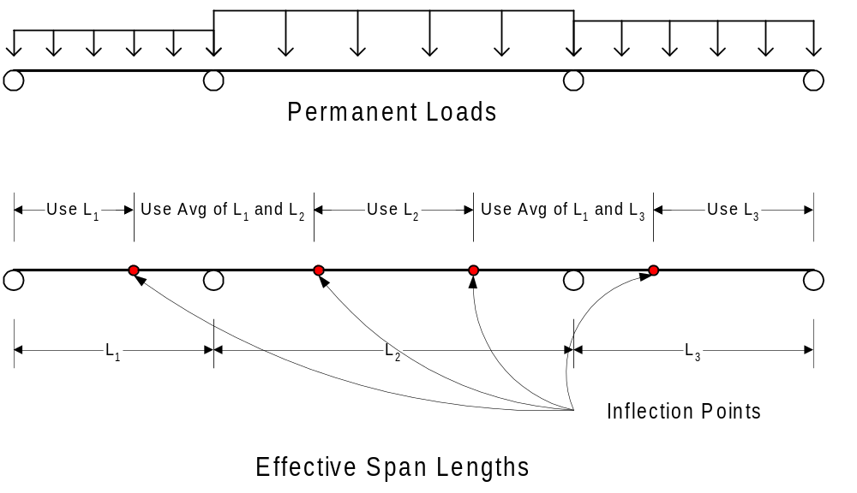
Figure 3 Effective Span Lengths for computing Effective Flange Width at Different Locations along a Bridge
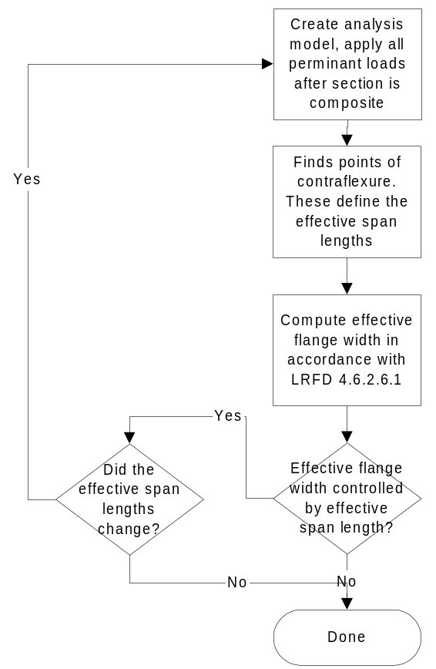
Figure 4 Procedure for computing Effective Flange Width

Effective Slab Depth
The effective slab depth is equal to the gross slab depth less the sacrificial depth. For exterior beams, the effective slab depth varies between the depth at the edge of the slab and the effective depth of the main slab.
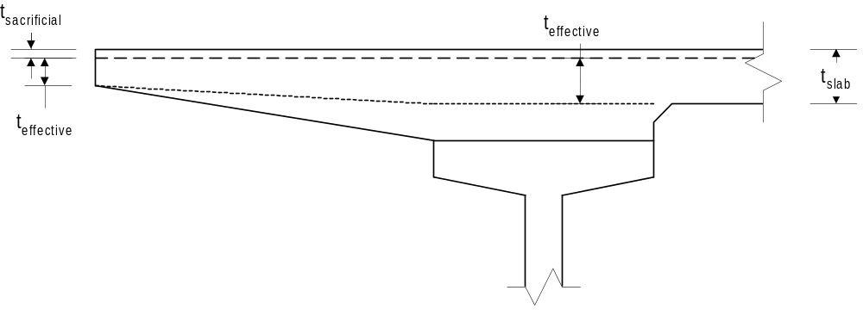
Figure 5 Effective Slab Depth

Cap Beams
Only one set of section properties need to be computed for cap beams. The cross sectional area and moment of inertia need to be computed. Cap Beam section properties only apply to TBAM's.

Columns
Only one set of section properties needs to be computed for columns. Column properties are required for cross sectional area and moment of inertia about axes transverse and longitudinal to the plane of the pier.
For LBAM's the cross sectional area and moment of inertia are summed for all columns and then divided by the number of girder lines. If the pier is skewed, the section properties are transformed into a coordinate system that is transverse and longitudinal to the alignment at the location of the pier. The moment of inertia for bending about an axis normal to the alignment is used in the analysis model. The product of inertia will likely be non-zero in this case, but will be ignored, as the analysis method used by QConBridge II does not account for the skew effects except as provided for in the live load distribution factors, and for load transfer between LBAM’s and TBAM’s (see Section below).
For TBAM's, the cross sectional area and moment of inertia for bending about an axis normal to the bent for each individual column are used.

Live Load Distribution Factors
Live load distribution factors are used to approximate the amount of live load a single girder line will carry. For BAM Projects, the user is responsible for determining the appropriate distribution factors and inputting them into the program. For Product Model Projects, QConBridge II will compute live load distribution factors with applicable LRFD and WSDOT criteria.

Cross Section Types
For the purpose of computing live load distribution factors, precast girder bridge product models are classified as cross section type K and rolled steel beams and built-up plate girder bridge product models are classified as cross section type A.

Method of Calculation
Live load distribution factors are computed in accordance with LRFD 4.6.2.2. If the WSDOT BDM option is selected, distribution factors for precast girders will be computed in accordance with Design Memorandum 2-1999.

Span Length used in Calcuations
The span length parameter L will be determined in accordance with table C4.6.2.2.1-1. Table C4.6.2.2.1-1 does not cover the case of interior reactions of simple spans (multi-span bridge without moment continuity between spans). For this case, L will be taken as the length of the longer of the adjacent spans.
In the rare occasion when the continuous span arrangement is such that an interior span does not have any positive uniform load moment, i.e., no uniform load points of contraflexure, the region of negative moment near the interior supports would be increased to the centerline of the span, and the L used in determining the live load distribution factors would be the average of the two adjacent spans.

Skew Correction Factors
When the lines of support are skewed the distribution factors must be adjusted to account for skew effects. Skew adjustment for moments are given in LRFD 4.6.2.2.2e. Skew adjustments for shear are given in LRFD 4.6.2.2.3c.
For the purposes of computing the skew correction factors the skew angle will be defined as:
Force Effect | Skew Angle
Moment | Average skew angle of the adjacent supports
Shear | Average skew angle of the adjacent supports
Reactions | Skew angle at the pier where the reaction occurs
Table 1 Skew Angle for computing Skew Correction Factors

Distribution Factors for Reactions
Distribution factors for reactions are not specifically defined in the LRFD specification, though they are alluded to in table C4.6.2.2.1-1. For type A and K cross sections, shear distribution factors are independent of span length, except when they are corrected for skew. QConBridge II will use the basic shear distribution factors for reactions, and adjust them for skew using the span lengths defined in Section 5.3 and skew angles defined in Section 5.4
Support elements that are modeled with a column member generate reactions for moment, axial, and shear forces. Vertical loads imparted onto the substructure from the superstructure generate these force effects. For this reason, the distribution factors for reaction will be applied to all three of these reaction components.

Distribution Factors for Deflection
When computing live load deflections the live load distribution factors for moments shall be used, except when computing deflections for evaluation of LRFD 2.5.2.6. For upward deflections, the distribution factor for negative moment will be used. For downward deflections, the distribution factor for positive moment will be used.
When computing live load deflections for the truck and lane configuration defined in LRFD 3.6.1.3.2 for use in evaluating LRFD 2.5.2.6, the procedure defined in Section 6.4.1 shall be used.

Distribution Factors for Rotations
When computing rotations due to live load the distribution factors for moment shall be used. For rotations relating to negative moments near the support, QconBridge II shall use the negative moment distribution factor. For rotations relating to positive moments near the support, QconBridge II shall use the positive moment distribution factor.

Distribution of Pedestrian Live Load
The LRFD Specification does not provide guidance for the distribution of pedestrian live load to a girder line. Because pedestrian live load is a uniform load applied to a sidewalk, QConBridge II will distribute it the same way the uniform sidewalk dead load is distributed. Distribution of sidewalk dead load is described in Section below.

Longitudinal Bridge Analysis Models
The primary reason that Bridge Product Models are used in QConBridge II is to provide a simplified, efficient, and intuitive way to describe a bridge structure. Before a longitudinal structural analysis can be performed on a Product Model bridge, it must be idealized as a LBAM. The process of idealization is called Model Generation. This Section describes the modeling techniques and assumptions used when generating LBAM’s from the Product Models supported by QConBridge II.

Model Topology
The basic topology of a LBAM is similar for all types of slab on girder bridges. Figure 6 shows the mapping from a product model to an analysis model for a typical slab on girder bridge.
Note that Figure 6 leaves out much detail. Details are given in the Sections following.
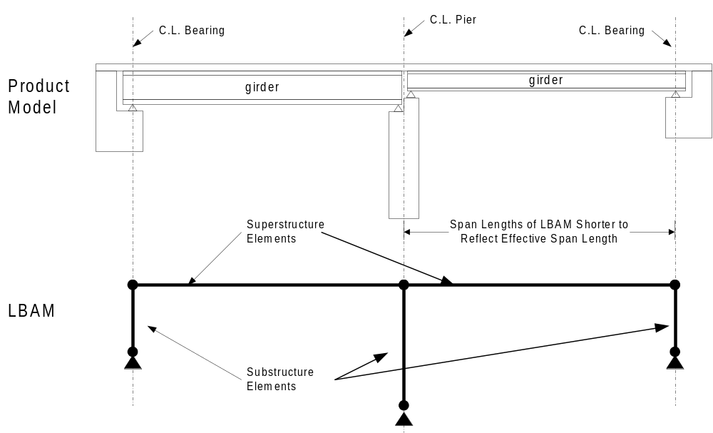
Figure 6 Model Geometry for Slab on Girder Bridges

Superstructure Elements
For the simplified method of analysis, the superstructure is divided into girder lines and each girder line is analyzed independently. Superstructure elements are modeled between points of bearing as a series of prismatic segments. The first segment begins at the left edge of a span. The remaining segments continue end to end until the right edge of the span is reached. The span length of the superstructure elements is taken to be the flexible span length as described in Section above.

Substructure Elements
This Section describes how the product model descriptions of substructure elements are represented in the LBAM. Note that substructure elements need not be modeled consistently between the LBAM and the corresponding TBAM. For example, in the LBAM, a substructure element can be modeled as a knife-edge idealization and in the TBAM could represent the same pier as a complete 2D bent model.

Abutments
This section describes how abutment product models are described in the LBAM.

Zero-Height Idealized Abutments
Figure 7 shows how this type of abutment is modeled. The location of the support is located at the centerline of bearing. Note that the bearing heights from the connection are ignored.
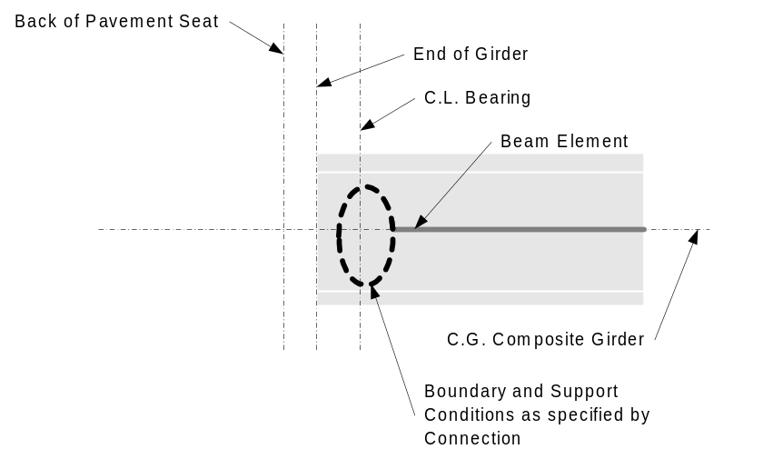
Figure 7 BAM Detail for Zero-Height Idealized Abutments

Fixed-Height Idealized Abutments
Figure 8 shows how this type of abutment is modeled. Note that bearing heights from the connection and girder height are ignored.
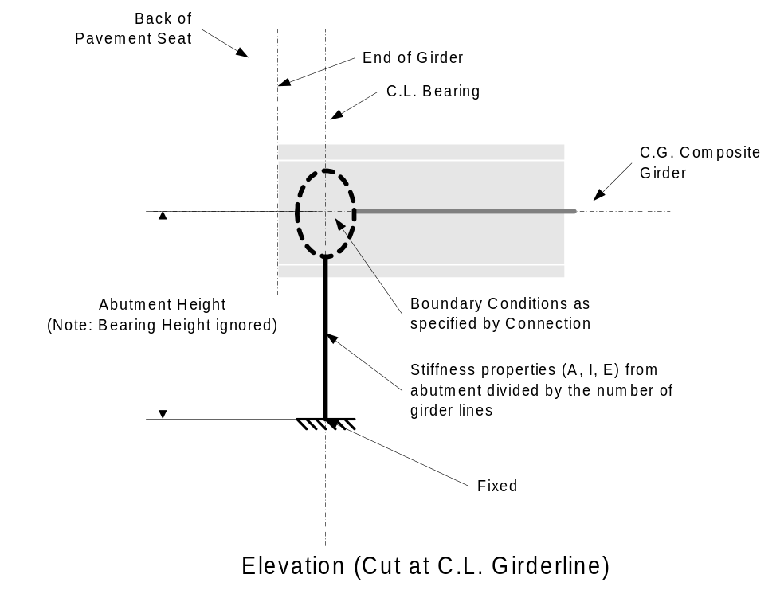
Figure 8 BAM Detail for Fixed-Height Idealized Abutments

Piers
Pier product models can be 2D or 3D zero height idealized, 2D or 3D fixed height idealized, or full product models. LBAMs are only concerned about the components of the pier product description dealing with the longitudinal force analysis for 3D and full product models. Pier connections can be Continuous, Simply Supported, or Simply Supported made Continuous.

Zero-Height Idealized Piers
shows how zero height piers are modeled for continuous and simple support connections. Note that bearing heights from the connection are ignored and for the simple support condition, the left and right bearings share a common point of support located at the centerline of the pier.
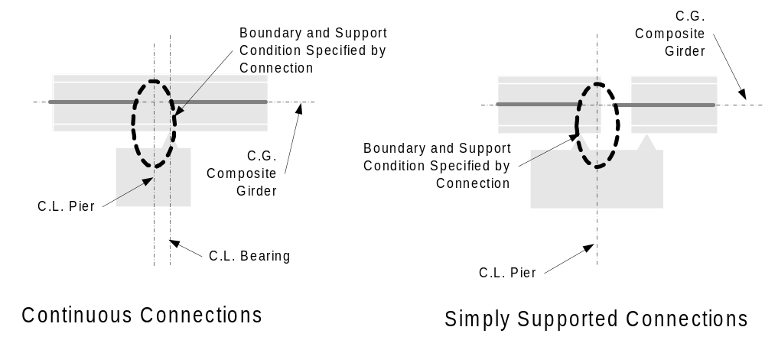
Figure 9 LBAM Model of Zero-Height Idealized Piers

Fixed Height Idealized Piers
Figure 10 shows how fixed height piers are modeled for continuous and simple support connections. The analysis model supports correspond to the centerline pier in the product model. Note that bearing heights from the connection and the vertical height between the girder C.G. and the top of the cap are ignored. For the simple support condition, the left and right bearings share a common point of support located at the centerline of the pier.
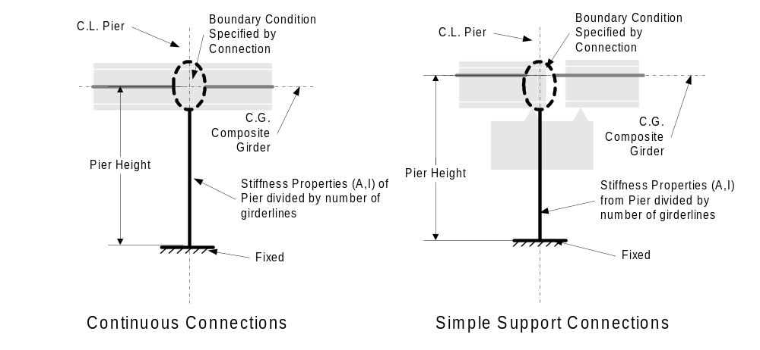
Figure 10 LBAM Model of Fixed-Height Idealized Piers

Full Product Model Piers
The modeling of full product model piers is shown in Figure 11 for continuous and simple support connections. Note that this model takes the entire height of the product model pier into account including bearing heights. If bearing heights differ due to different girder depths, the average bearing height and average Y_{cg} for the girder are used.
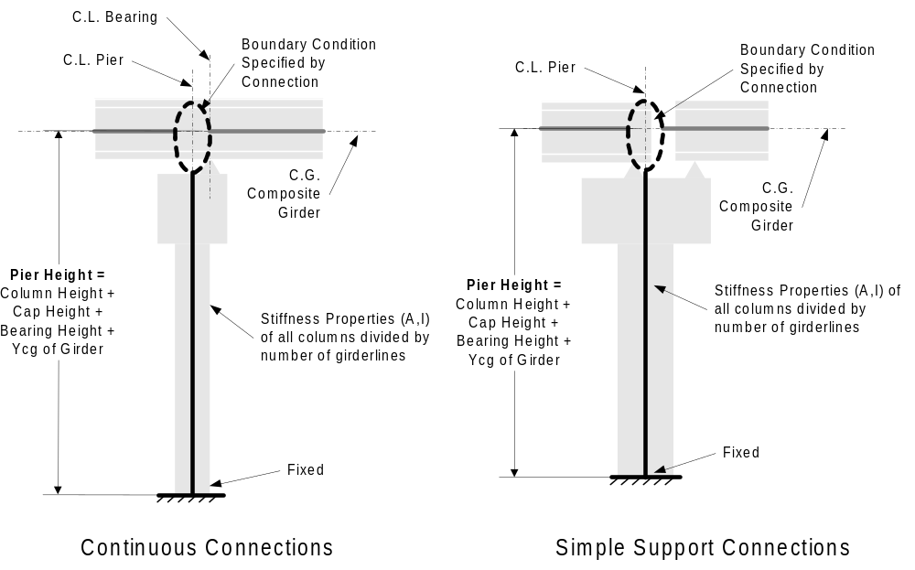
Figure 11 LBAM Modeling of Full Product Model Piers
The column height is computed as the difference between the top of column and bottom of column elevations. The top of column elevation is computed by tracing the elevation at the roadway surface at the intersection of the survey line and the centerline of the pier, along the roadway surface to the reference girder, down the depth of the reference girder to the cap beam, along the top surface of the cap beam to the centerline of the column and down the depth of the cap beam at the column. If the columns are different height, the average column height is used. This is shown in Figure 12.
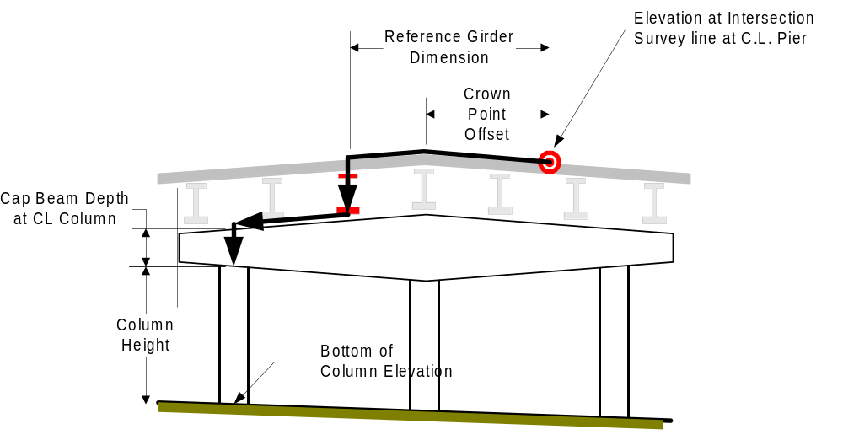
Figure 12 Column Height when Bottom Elevation is specified

Modeling Connections
Connections define the boundary conditions between adjacent superstructure members and the boundary conditions between superstructure members and substructure members. For zero height abutments and piers, connections define the support condition as well.
The sections that follow illustrate how product model connections are mapped to analysis model connections for the various combinations of support type and connection type.

Abutment Connection

Abutment Connection on a Zero Height Abutment
Depending on the connection description, an abutment connection on a zero height abutment is modeled as a pinned or roller support.
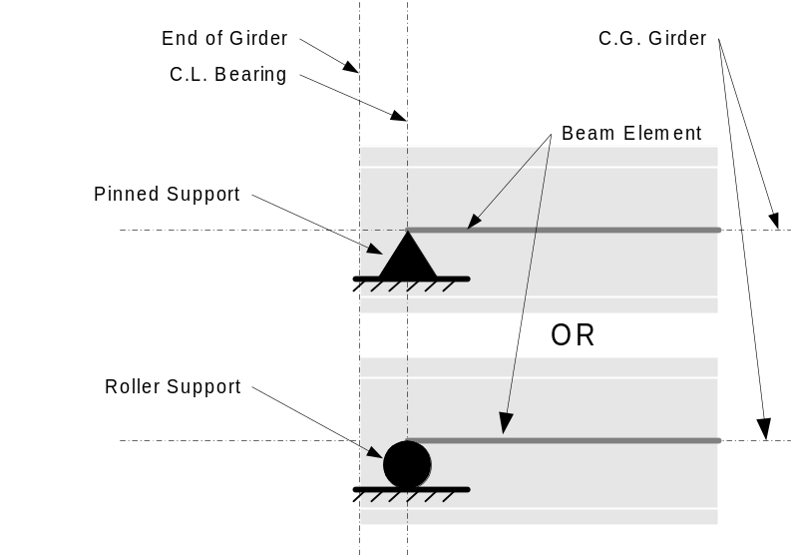
Figure 13 Abutment Connection on a Zero Height Abutment

Abutment Connection on a Fixed Height Abutment
Depending on the connection description, an abutment connection on a fixed height abutment is modeled as integral, hinged, or sliding.
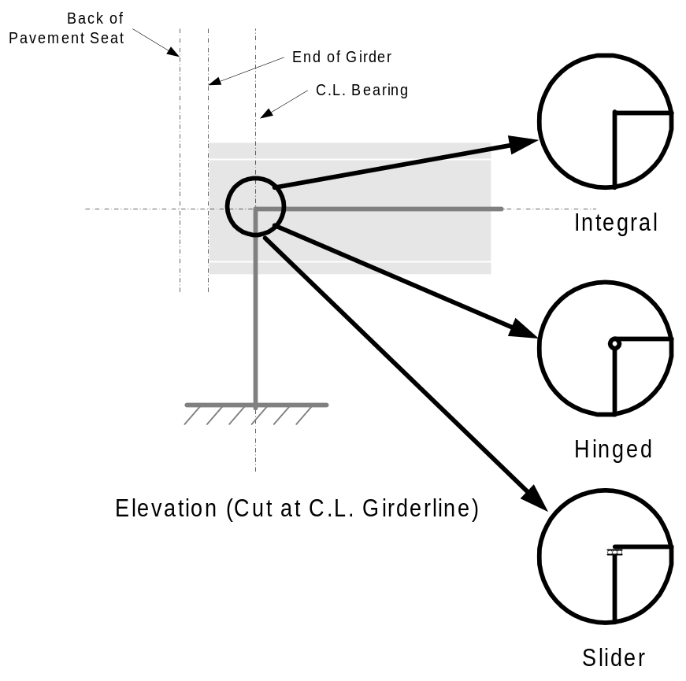
Figure 14 Abutment Connection on a Fixed Height Abutment

Continuous Pier Connection

Continuous Pier Connection on a Zero Height Pier
Depending on the connection description, a continuous pier connection on a zero height pier is modeled as a pinned or roller support.
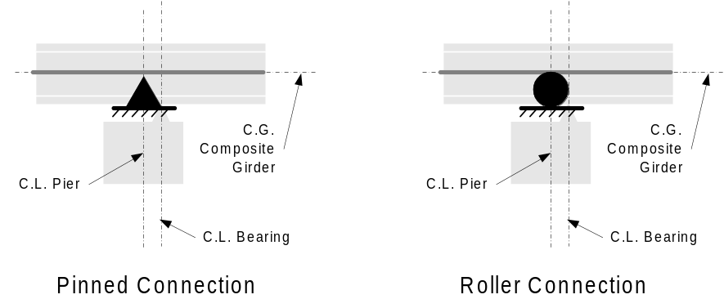
Figure 15 Continuous Pier Connection on a Zero Height Idealized Pier

Continuous Pier Connection on a Fixed Height Pier
A continuous pier connection on a fixed height pier is modeled with a hinge or slider at the top of the column member.
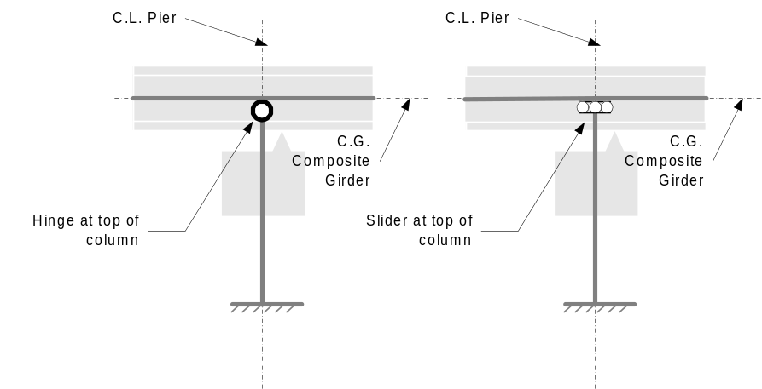
Figure 16 Continuous Pier Connection on a Fixed Height Idealized Pier

Continuous Pier Connection on a Full Product Model Pier
Connections for a full product model pier are the same as for Fixed Height Idealized Piers

Integral Pier Connection

Integral Pier Connection on a Zero Height Pier
Integral pier connections on zero height-idealized piers are modeled with a pinned support condition.
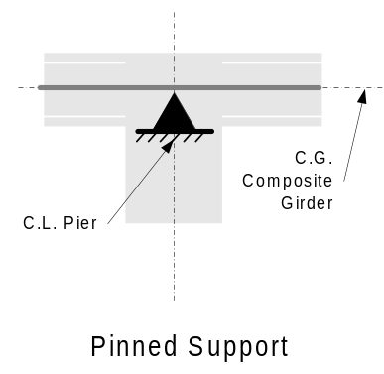
Figure 17 Integral Pier Connection on a Zero Height Idealized Pier

Integral Pier Connection on a Fixed Height Pier
Integral pier connections on fixed height idealized piers are modeled with an integral connection between the two superstructure elements and the column element.
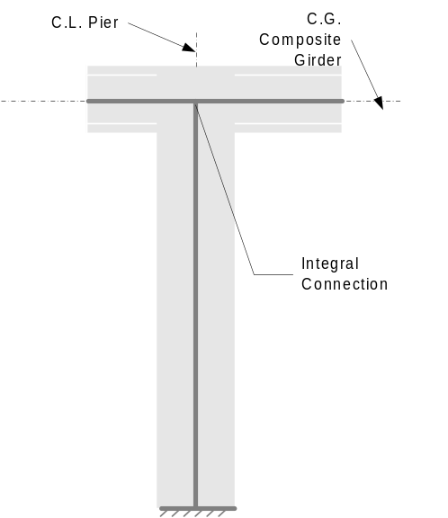
Figure 18 Integral Pier Connection on a Fixed Height Idealized Pier

Integral Pier Connection on a Full Product Model Pier
Connections for a full product model pier are the same as for Fixed Height Idealized Piers

Simple Support Pier Connection

Simple Support Pier Connection on a Zero Height Pier
Simple support pier connections on a zero height pier are modeled with pinned or roller supports and a hinge at the right end of the left span.
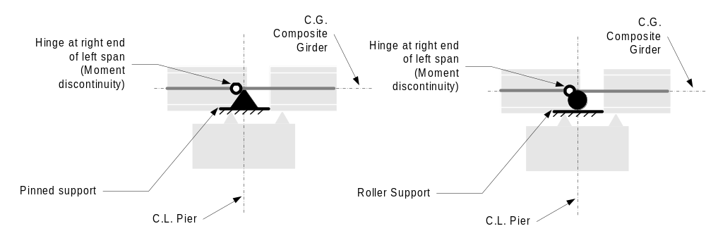
Figure 19 Simple Support Pier Connection on a Zero Height Idealized Pier

Made Continuous
If this connection is made continuous at some later stage in the analysis, the connection for that stage will be modeled as described in Section 6.1.3.2.1.

Made Integral
If this connection is made integral at some later stage in the analysis, the connection for that stage will be modeled as described in Section 6.1.3.3.1. Note that if a roller support is used in the simple span stage, it will be changed to a pinned support in the integral stage.

Simple Support Pier Connection on a Fixed Height Pier
Simple support pier connections on a fixed height pier are modeled with hinges at the ends of the spans framing into the connection. If the top of column is hinged, the hinge at the left end of the right span is omitted.
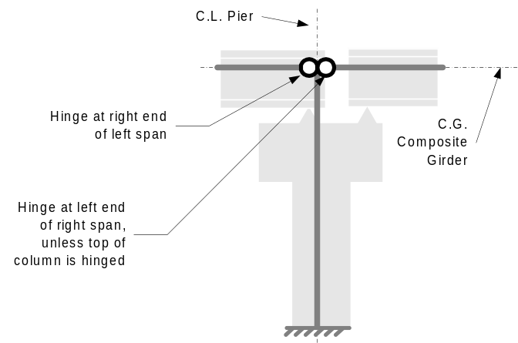
Figure 20 Simple Support Pier Connection on a Fixed Height Idealized Pier

Made Continuous
If this connection is made continuous at some later stage in the analysis, the connection for that stage will be modeled as described in Section 6.1.3.2.2.

Made Integral
If this connection is made integral at some later stage in the analysis, the connection for that stage will be modeled as described in Section 6.1.3.3.2.

Simple Support Pier Connection on a Full Product Model Pier
Connections for a full product model pier are the same as for Fixed Height Idealized Piers

Analysis Stages
QConBridge II supports staged analysis. Each bridge construction stage is modeled with a stage in the bridge analysis model. The analysis stage consists of a LBAM that represents the structure during the current stage and the loads that are applied to or removed from the structure during this stage.

Staged Analysis Constraints
There are two constraints that must be imposed on the stages of analysis models. The first constraint is that boundary conditions can only be added. For example, a hinge can be added to a span, but one cannot be taken away. The second constraint is that the member stiffness parameters (A, I and E) must not decrease as the stage number increases.
With the product models supported by QConBridge II, this is not a concern. These constraints are adhered to by the very nature of the product models supported by the software.

Loads
The sections that follow describe how the various loads are generated from the product model description and applied to the LBAM.

Dead Load
Product model dead loads for longitudinal analysis consists of the self weight of the girders, roadway slab, end diaphragms, intermediate diaphragms, traffic barriers, median barriers, sidewalks, and overlays. This section describes how these loads are computed and represented in LBAM's.
Permanent loads of and on the roadway slab may either be distributed uniformly over all the girder lines (See LRFD 4.6.2.2.1) or may be distributed based on tributary areas and simple distribution rules (WSDOT Design Practice). This section will describe how the dead loads are computed and applied to the LBAM's for both cases. When the loads are evenly distributed over all girders, the loads specified in Section 6.3.1.1.8, except for girder self weight, are not applied to the analysis models.

Load in Main Span
Superimposed dead loads are applied to the main span, between the centerlines of bearing as a uniform load or a series of linear load segments as appropriate. The figure below illustrates how superimposed dead loads in the main span are modeled.
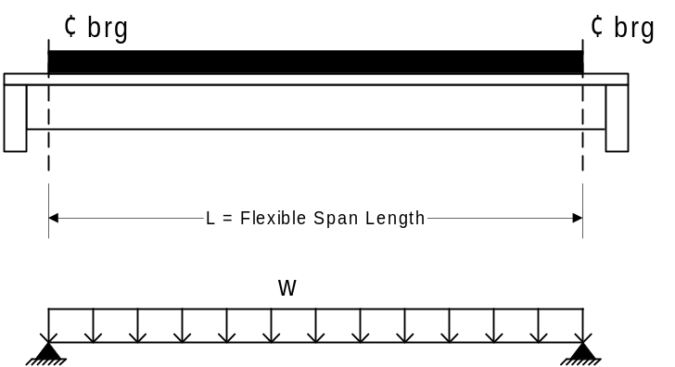
Figure 21 Modeling of Main Span Loads

Girder Self-Weight
The self-weight of the girder is modeled as a series of uniform load segments that correspond to the segments in the product model. The intensity of a load segment is taken to be 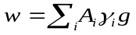where,
w | Intensity of the uniform load
A_{i} | Cross-sectional area of the i^{th} element
γ_{i} | Density of the material for the i^{th} element of the cross section
g | gravitational acceleration
i | i^{th} element in the cross section

Slab

Uniform Distribution to All Girder Lines
The load per girder line using a uniform distribution of the slab load is taken to be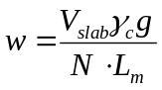where,
w | Intensity of the uniform load
V_{slab} | Volume of the slab
γ_{c} | Density of the slab concrete
g | gravitational acceleration
N | Number of girder lines
L_{m} | Total length of the analysis model to which this load is applied
The volume of the slab is taken to be 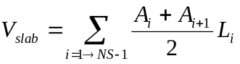 where,
V_{slab} | Volume of the slab
A_{i} | cross section area of the slab, including the slab pad, at section i
L_{i} | Distance between section i and i+1, measure along the center line of the bridge
NS | Number of sections. Slab sections begin and end at the ends of the girders at the start and end of the bridge and occur at all points of interest.

Distribution of Load to Girder Lines Based on Tributary Area
This section describes how the slab load is distributed to girder lines based on tributary area. The slab load is divided into two parts; the main slab and the slab pad.

Main Slab
The load from the main portion of the slab on interior girders is a uniform load along the entire length of the girder line. For exterior girders, the main slab loads varies with location due to the thickening of the overhang at the exterior girder and curvature of the slab edge.

Interior Girders
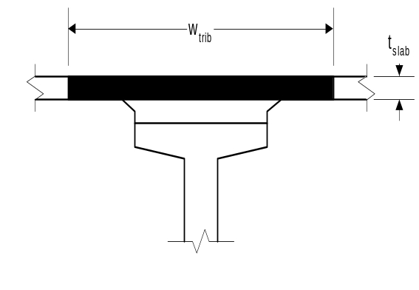
Figure 22 Tributary Slab Width
The main slab load for interior girders is 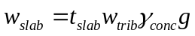, where:
w_{slab} | Main slab load
t_{slab} | Gross thickness of the slab
w_{trib} | Tributary width of the slab
γ_{c} | Weight density of slab concrete
g | Gravitational acceleration

Exterior Girders
The main slab load for an exterior girder line is divided into two parts; one for the inboard side and one for the outboard side. On the inboard side, the slab load is uniform. On the outboard side, the slab load varies with the haunch and curvature of the slab edge.
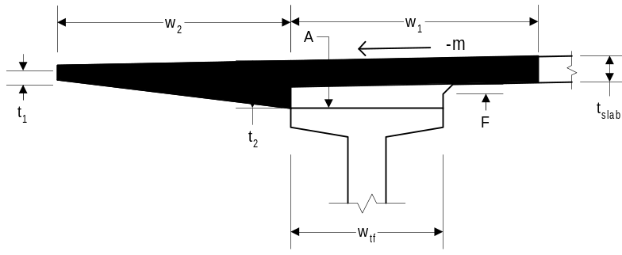
Figure 23 Tributary Slab Width for an Exterior Girder

Inboard Side
The load for the main slab on the inboard side of exterior girders is taken to be 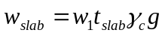, where
w_{slab} | Main slab load
t_{slab} | Gross thickness of the slab
w₁ | Tributary width of the slab, computed as half the distance to the next girder plus half of the top flange width. For curved structures, with straight girders, w₁ must be divided by the cosine of the angle formed between a radial line passing through the point under consideration and a line that is normal to the girder.
γ_{c} | Weight density of slab concrete
g | Gravitational acceleration

Outboard Side
The intensity of the load on the outboard side of exterior girders at any point in the span is taken to be
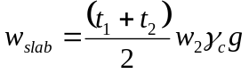
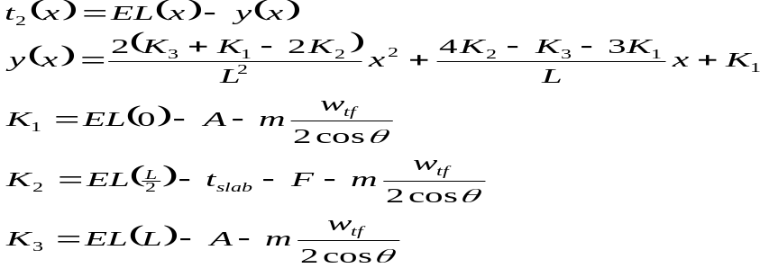
where
w_{slab} | Main slab load
t_{slab} | Gross thickness of the slab
w₂ | Tributary width of the slab, computed as the distance from the centerline of the girder to the edge of the slab, measured normal to the alignment. For curved structures, with straight girders, w₂ must be divided by cosθ to account for the girder not being parallel to the tangent to the alignment.
γ_{c} | Weight density of slab concrete
g | Gravitational acceleration
x | Distance along the girder, measure from the centerline of bearing
EL(x) | The elevation of the surface of the roadway at x, directly above the outboard side of the top flange.
L | Bearing to bearing span length (flexible span length)
F | Depth of fillet (distance from top of girder to top of slab at mid-span is assumed to be t_{slab}+F).
A | Distance from top of girder to top of slab, measured at the intersection of centerline bearing and centerline girder.
y(x) | Elevation of the outboard edge of the top flange. It is assumed that the top flange of the girder forms a parabolic shape along its length.
m | Crown slope at x
θ | Angle between the vector that is normal to the alignment, passing though x, and a vector that is normal to the girder line.
w_{tf} | width of the top flange, measured normal to the girder
The main slab load on the outboard side of exterior girders will be applied linearly between all points of interest.

Slab Pad (Haunch)
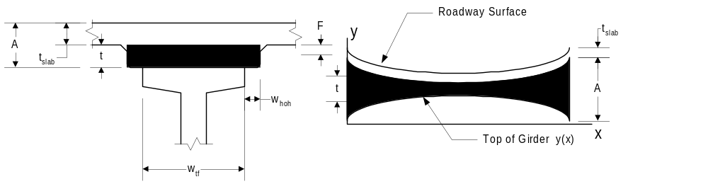
Figure SEQ Figure \* ARABIC 24 Slab Pad (Haunch) Load
The slab pad, or haunch, is defined to be that area of concrete between the main slab and the girder. The slab pad has a constant width, but its depth varies due to the effects of camber and vertical curvature of the roadway surface. The slab pad load is approximated with segments of linear loads. The intensity of the linear load at any point is taken to be:
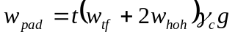
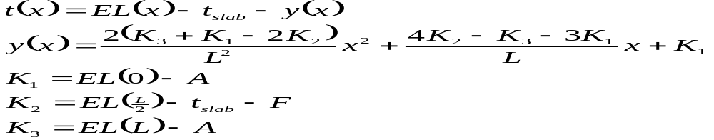
where
w_{pad} | Slab pad load
t(x) | Depth of the slab pad at point x
w_{tf} | Width of the top flange
w_{hoh} | Width of the haunch overhang
γ_{c} | Weight density of slab concrete
g | Gravitational acceleration
x | Distance along the girder, measured from the centerline of bearing
EL(x) | The elevation of the surface of the roadway at x, directly above the outboard side of the top flange.
L | Bearing to bearing span length (flexible span length)
F | Depth of fillet (distance from top of girder to top of slab at mid-span is assumed to be t_{slab}+F).
A | Distance from top of girder to top of slab, measured at the intersection of centerline bearing and centerline girder. Value is equal at both ends of the girder.
y(x) | Elevation of the outboard edge of the top flange. It is assumed that the top flange of the girder forms a parabolic shape along its length.

Intermediate Diaphragms
Intermediate diaphragm loads are applied to the main span as concentrated loads. The loads are positioned in accordance with the diaphragm layout rules specified by the product model. The magnitude of the load is computed differently depending on product model type.

Precast Girder Bridge Product Models
For precast girder bridge product models, the magnitude of the intermediate diaphragm load is computed as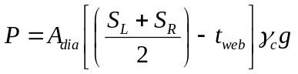for interior girders and 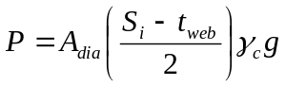 for exterior girders, where
P | Magnitude of the load
A_{dia} | Cross sectional area of the diaphragm
γ_{c} | Weight density of slab concrete
g | Gravitational acceleration
S_{L} | Girder spacing on the left hand side
S_{R} | Girder spacing on the right hand side
S_{i} | Girder spacing on the side of the interior girder
t_{web} | Width of the web

Steel Beam Bridge Product Models
For steel beam bridge product models (built-up and rolled shapes), the product model of the intermediate diaphragms is described by a uniform load along the diaphragm, which is transverse to the girder. The magnitude of the intermediate diaphragm load is taken to be 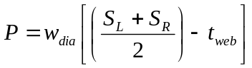 for interior girder lines and 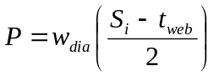 for exterior girder lines where
P | Magnitude of the load
w_{dia} | weight per unit length of the diaphragm transverse to the girder line
S_{L} | Girder spacing on the left hand side
S_{R} | Girder spacing on the right hand side
S_{I} | Girder spacing on the side of the interior girder
t_{web} | Width of the web

Traffic Barrier Load
The traffic barrier load is applied to the main span as a uniform load. The intensity of the traffic barrier load is 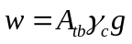where
w | Load intensity for the entire traffic barrier
A_{tb} | Cross sectional area of the traffic barrier
γ_{c} | Weight density of slab concrete
g | Gravitational acceleration

Uniform Distribution of Load to All Girder Lines
In accordance with LRFD 4.6.2.2.1, the total traffic barrier load is distributed evenly over all girder lines. The total traffic barrier load is computed as 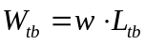, where W_{tb} is the total weight of the traffic barrier and L_{tb} is the length of the traffic barrier, measured from back of pavement seat to back of pavement seat and adjusted for the connections at the first and last pier. The load per girder is taken to be 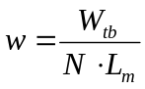, where N is the number of girder lines and L_{m} is the length of the LBAM that the load is applied to.

Distribution of Load to Exterior Girder Lines
Alternatively, the load can be distributed over n exterior girder lines, if there is 2n or more girder lines, otherwise the load per girder line is 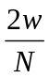, where N is the number of girder lines. If the traffic barriers on the left and right side of the bridge differ and the number of girder lines is less than 2n the load per girder line is 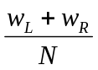, where w_{L} and w_{R} are the intensities of the left and right loading respectively.

Median Barrier Loads
Median barrier loads are applied to the main span as a uniform load. The basic load is 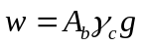where
w | Load intensity for the entire barrier
A_{b} | Cross sectional area of the barrier
γ_{c} | Weight density of slab concrete
g | Gravitational acceleration

Uniform Distribution of Load to All Girder Lines
In accordance with LRFD 4.6.2.2.1, the total barrier load is distributed evenly over all girder lines. The total barrier load is computed as 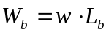, where W_{b} is the total weight of the barrier and L_{b} is the length of the barrier, measured from back of pavement seat to back of pavement seat and adjusted for the connections at the first and last pier. The load per girder is take to be 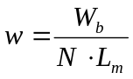, where N is the number of girder lines and L_{m} is the length of the LBAM that the load is applied to.

Distribution of Load to Adjacent Girder Lines
Alternatively, the load can be distributed over the n nearest girder lines. If the total number of girder lines, N, is less than n, then the barrier load is evenly distributed amongst all girder lines. If the case occurs where there are two outer girders that are equidistant from the barrier location, and this makes the total number of girders equal to n+1, the load will be distributed evenly over n+1 girders.

Sidewalks
The sidewalk load is applied to the main span as a uniform load. The intensity of the sidewalk load is 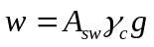where
w | Load intensity for the entire traffic barrier
A_{sw} | Cross sectional area of the sidewalk
γ_{c} | Weight density of slab concrete
g | Gravitational acceleration

Uniform Distribution of Load to All Girder Lines
In accordance with LRFD 4.6.2.2.1, the total sidewalk load is distributed evenly over all girder lines. The total sidewalk load is computed as 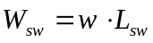, where W_{sw} is the total weight of the sidewalk and L_{sw} is the length of the sidewalk, measured along its centerline from back of pavement seat to back of pavement seat and adjusted for the connections at the first and last pier. The load per girder is take to be 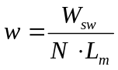, where N is the number of girder lines and L_{m} is the length of the LBAM that the load is applied to.

Distribution of Load to Exterior Girder Lines
Alternatively, the load can be distributed over n exterior girder lines, if there is 2n or more girder lines, otherwise the load per girder line is , where N is the number of girder lines. If the sidewalk on the left and right side of the bridge differ and the number of girder lines is less than 2n the load per girder line is , where w_{L} and w_{R} are the intensities of the left and right loading respectively.

Overlay Loads
When roadway surfacing is present dead load must be accounted for.

Uniform Distribution of Load to All Girder Lines
In accordance with LRFD 4.6.2.2.1, the total overlay load is distributed evenly over all girder lines. The uniform load for a girder line, based on the total overlay load, is computed as 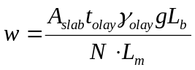, where
w | Uniform load intensity
A_{slab} | Surface area of the slab receiving the overlay material
t_{olay} | Thickness of the overlay
γ_{olay} | Density of the overlay material
g | Gravitational acceleration
L_{b} | Length of the bridge back of pavement seat to back of pavement seat and adjusted for connections at the first and last piers
N | Number of girder lines
L_{m} | Length of the longitudinal bridge analysis model to which this load is applied

Distribution of Load to Girder Lines Based on Tributary Area
Alternatively, the overlay load may be distributed to girder lines based on its tributary area. The dead load is computed as 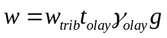, where
w | Load intensity for the specified tributary width
w_{trib} | Tributary width
t_{olay} | Thickness of the overlay
γ_{olay} | Density of the overlay material
g | Gravitational acceleration

Bottom Laterals on Built-Up Steel Beams
Built-Up Steel Plate Girder Bridge Product Models describe bottom laterals as a weight per length for each girder line. For LBAM's, this load is applied along the flexible span length of the model.

Loads in Connection Region
A portion of the load due to bridge components extends beyond the points of bearing for most connection types. The product model of the connection defines the geometry of the end of the girder, and how this load is applied to the structure. The connection definitions specify if the loads beyond the point of bearing are supported by the girder, applied directly to the bearing, or are ignored. This section describes how the product model loads in connection regions are represented in analytical models.
When loads in the main span are applied using a uniform distribution over all girder lines, the loading defined in this section is not applied to the analysis model. Girder self weight loads, as defined in this section, are always applied to the analysis models.

Abutment Connections
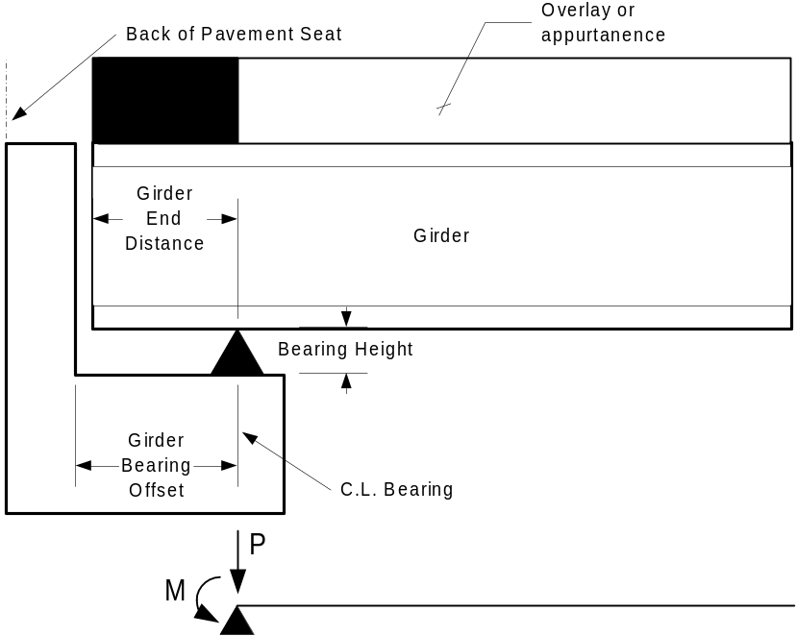
Figure 24 Abutment Connection Loads
Product model loads for abutment connections are represented by an equivalent concentrated force and moment applied to the support point when the load is imposed on the girder. When the load is imposed directly on the support, only the concentrated load is applied.
Note that Girder End Distance is measured normal to the back of pavement seat. The Girder End Distance must be corrected for skew.

Girder Self Weight
The equivalent loads are given by:
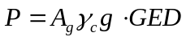
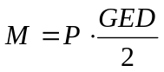
where
P | Equivalent concentrated force
M | Equivalent concentrated moment
A_{g} | Area of the girder
γ_{c} | Density of concrete
g | Gravitational acceleration
GED | Girder End Distance

Slab
The equivalent loads are given by:
where
P | Equivalent concentrated force
M | Equivalent concentrated moment
w_{trib} | Tributary width of the slab at the centerline bearing
t_{slab} | Gross slab thickness
A | Distance from top of girder to top of slab at intersection of the centerline of girder and the centerline of bearing
w_{tf} | Width of the top flange of the girder
w_{oh} | Width of the haunch overhang
γ_{c} | Density of concrete
g | Gravitational acceleration
GED | Girder End Distance

End Diaphragms
End diaphragm loads are applied to the ends of the analysis models as concentrated loads and moments. The product connection description specifies if the diaphragm load is applied to the end of the girder or directly to the bearing.
The magnitudes of the loads are computed differently depending on product model type.

Precast Girder Bridge Product Models
For precast girder bridge product models, the magnitude of the end diaphragm load is computed as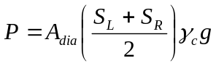for interior girders and 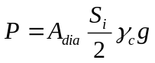 for exterior girders, where
P | Magnitude of the load
A_{dia} | Cross sectional area of the diaphragm (Computed as width times height)
γ_{c} | Weight density of slab concrete
g | Gravitational acceleration
S_{L} | Girder spacing on the left hand side
S_{R} | Girder spacing on the right hand side
S_{I} | Girder spacing on the side of the interior girder
The moment is taken to be 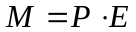where E is the distance from the centerline of bearing to the point of application of P.

Steel Beam Bridge Product Models
For steel beam bridge product models (built-up and rolled shapes), the end diaphragms are described by a uniform load transverse to the girder. The magnitude of the end diaphragm load is taken to be 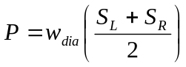 for interior girder lines and 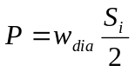 for exterior girder lines where
P | Magnitude of the load
w_{dia} | weight per unit length of the diaphragm transverse to the girder line
S_{L} | Girder spacing on the left hand side
S_{R} | Girder spacing on the right hand side
S_{I} | Girder spacing on the side of the interior girder
The moment is taken to be where E is the distance from the centerline of bearing to the point of application of P.

Traffic Barrier
The equivalent loads are given by:
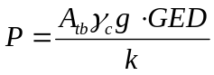
where
P | Equivalent concentrated force
M | Equivalent concentrated moment
A_{tb} | Area of the traffic barrier
γ_{c} | Density of concrete
g | Gravitational acceleration
GED | Girder End Distance
k | A factor representing the distribution of the traffic barrier weight amongst the exterior girder lines. See 6.3.1.1.4.2 for details.

Median Barriers
The equivalent loads are given by:
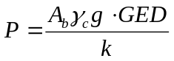
where
P | Equivalent concentrated force
M | Equivalent concentrated moment
A_{b} | Area of the median barrier
γ_{c} | Density of concrete
g | Gravitational acceleration
GED | Girder End Distance
k | A factor representing the distribution of the barrier weight amongst the nearby girder lines. See 6.3.1.1.5.2 for details.

Sidewalks
The equivalent loads are given by:
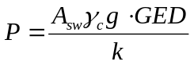
where
P | Equivalent concentrated force
M | Equivalent concentrated moment
A_{sw} | Area of the sidewalk
γ_{c} | Density of concrete
g | Gravitational acceleration
GED | Girder End Distance
k | A factor representing the distribution of the sidewalk weight amongst the exterior girder lines. See 6.3.1.1.6.2 for details.

Overlay
The equivalent loads for overlays are:
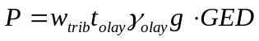
P | Equivalent concentrated force
M | Equivalent concentrated moment
w_{trib} | Tributary width, measured at the point of bearing
t_{olay} | Thickness of the overlay
γ_{olay} | Density of the overlay material
g | Gravitational acceleration
GED | Girder end distance

Continuous Pier Connection
For a continuous pier connection, all of the loads in the connection region, except for diaphragm loads, are represented in the main span portion of the analysis model.

End Diaphragms
End diaphragm loads are applied to the support points of the analysis models as concentrated loads, if the product description of the connection specifies that the diaphragm weight should be included in the analysis models.
The magnitude of the load is computed differently depending on product model type.

Precast Girder Bridge Product Models
For precast girder bridge product models, the magnitude of the end diaphragm load is computed asfor interior girders and for exterior girders, where
P | Magnitude of the load
A_{dia} | Cross sectional area of the diaphragm (Computed as width times height)
γ_{c} | Weight density of slab concrete
g | Gravitational acceleration
S_{L} | Girder spacing on the left hand side
S_{R} | Girder spacing on the right hand side
S_{I} | Girder spacing on the side of the interior girder

Steel Beam Bridge Product Models
For steel beam bridge product models (built-up and rolled shapes), the product model of the end diaphragms is described by a uniform load transverse to the girder. The magnitude of the end diaphragm load is taken to be for interior girder lines and for exterior girder lines where
P | Magnitude of the load
w_{dia} | weight per unit length of the diaphragm transverse to the girder line
S_{L} | Girder spacing on the left hand side
S_{R} | Girder spacing on the right hand side
S_{I} | Girder spacing on the side of the interior girder

Simple Support Pier Connection
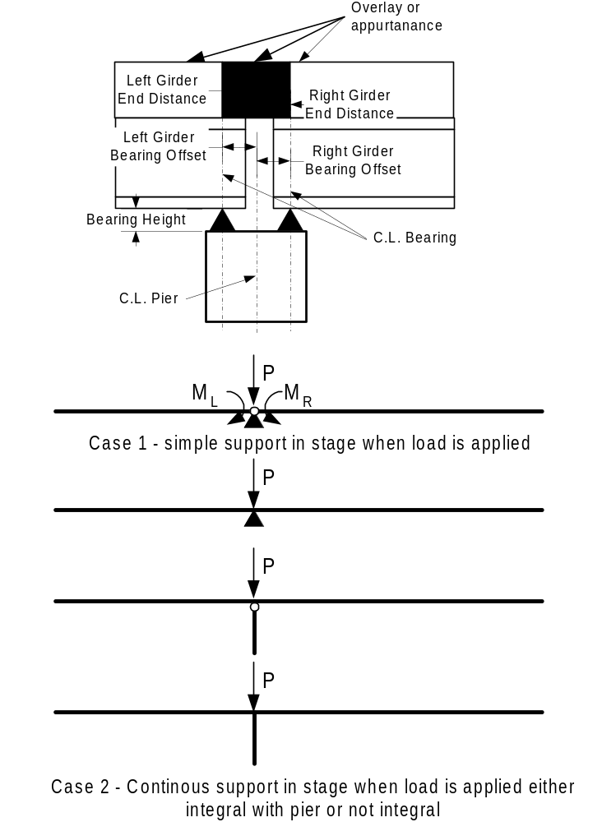
Figure 25 Simple Support Pier Connection Loads
Simple span support conditions can change to continuous support conditions in a given stage. To correctly apply the loads in this connection region, consideration must be given to the connection type at time of loading. The loading of the connection region is described by two cases. Case 1 is for application of loading during a stage with simple support condition. Case 2 is for application of load during a stage with continuous support conditions.
Product model loads for this connection type are represented by an equivalent concentrated force and moment applied to the support point when the load is imposed on the girders. When the load is imposed directly on the support, only the concentrated load is applied.
Note that Girder End Distance is measured normal to the back of pavement seat. The Girder End Distance must be corrected for skew.

Case 1 - Loading for Simple Support Conditions
The product model of the simple support stage of this connection specifies if superimposed loads in the connection region are transferred to the girders or pier. If the loads are transferred to the girders, concentrated moments are applied at the ends of the girders and a concentrated vertical load is applied directly to the support point. If the loads are transferred directly to the pier, only a concentrated load is applied at the connection point.

Case 2 - Loading for Continuous Support Conditions
If the load is applied to the connection region during a stage that has a continuous span connection, regardless of whether the superstructure is integral with the substructure, the load is modeled as a concentrated force and applied to the support point.

Equivalent Loads

Girder Self Weight
The equivalent loads are given by:
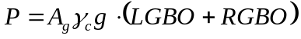
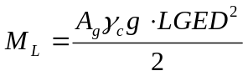
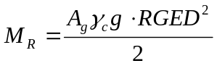
where
P | Equivalent concentrated force
M_{L} | Equivalent concentrated moment applied to the left hand girder
M_{R} | Equivalent concentrated moment applied to the right hand girder
A_{g} | Area of the girder
γ_{c} | Density of concrete
g | Gravitational acceleration
LGED | Left Girder End Distance
RGED | Right Girder End Distance
LGBO | Left Girder Bearing Offset
RGBO | Right Girder Bearing Offset

Slab
The equivalent loads are given by:
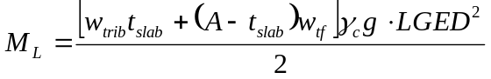
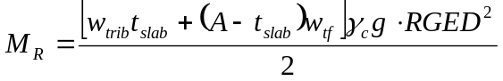
where
P | Equivalent concentrated force
M_{L} | Equivalent concentrated moment applied to the left hand girder
M_{R} | Equivalent concentrated moment applied to the right hand girder
w_{trib} | Tributary width of the slab at the centerline bearing
t_{slab} | Gross slab thickness
A | Distance from top of girder to top of slab at intersection of the centerline of girder and the centerline of bearing
w_{tf} | Width of the top flange of the girder
γ_{c} | Density of concrete
g | Gravitational acceleration
LGED | Left Girder End Distance
RGED | Right Girder End Distance
LGBO | Left Girder Bearing Offset
RGBO | Right Girder Bearing Offset

End Diaphragms

Precast Girder Bridge Product Models
For precast girder bridge product models, the equivalent load is only a concentrated force and taken to befor interior girders and , for exterior girders, where
P | Magnitude of the load
A_{dia} | Cross sectional area of the diaphragm (Computed as width times height)
γ_{c} | Weight density of slab concrete
g | Gravitational acceleration
S_{L} | Girder spacing on the left hand side
S_{R} | Girder spacing on the right hand side
S_{I} | Girder spacing on the side of the interior girder

Steel Beam Bridge Product Models
For steel beam bridge product models (built-up and rolled shapes), the product model of the end diaphragms is described by a uniform load transverse to the girder. The magnitude of the end diaphragm load is taken to be for interior girder lines and for exterior girder lines where
P | Magnitude of the load
w_{dia} | weight per unit length of the diaphragm transverse to the girder line
S_{L} | Girder spacing on the left hand side
S_{R} | Girder spacing on the right hand side
S_{I} | Girder spacing on the side of the interior girder

Traffic Barrier
The equivalent loads are given by:
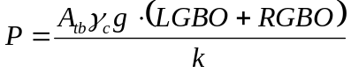
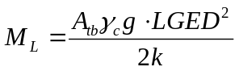
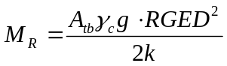
where
P | Equivalent concentrated force
M_{L} | Equivalent concentrated moment applied to the left hand girder
M_{R} | Equivalent concentrated moment applied to the right hand girder
A_{tb} | Area of the traffic barrier
γ_{c} | Density of concrete
g | Gravitational acceleration
LGED | Left Girder End Distance
RGED | Right Girder End Distance
LGBO | Left Girder Bearing Offset
RGBO | Right Girder Bearing Offset
k | A factor representing the distribution of the traffic barrier weight amongst the exterior girder lines. See 6.3.1.1.4.2 for details.

Median Barriers
The equivalent loads are given by:
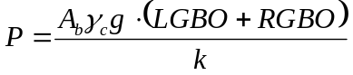
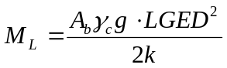
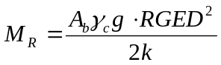
where
P | Equivalent concentrated force
M_{L} | Equivalent concentrated moment applied to the left hand girder
M_{R} | Equivalent concentrated moment applied to the right hand girder
A_{b} | Area of the barrier
γ_{c} | Density of concrete
g | Gravitational acceleration
LGED | Left Girder End Distance
RGED | Right Girder End Distance
LGBO | Left Girder Bearing Offset
RGBO | Right Girder Bearing Offset
k | A factor representing the distribution of the traffic barrier weight amongst the exterior girder lines. See 6.3.1.1.5.2 for details.

Overlay
The equivalent loads for overlays are:
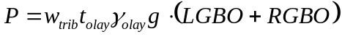
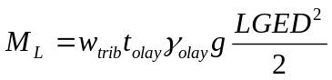
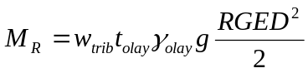
P | Equivalent concentrated force
M_{L} | Equivalent concentrated moment applied to the left hand girder
M_{R} | Equivalent concentrated moment applied to the right hand girder
w_{trib} | Tributary width, measured at the point of bearing
t_{olay} | Thickness of the overlay
γ_{olay} | Density of the overlay material
g | Gravitational acceleration
LGED | Left Girder End Distance
RGED | Right Girder End Distance
LGBO | Left Girder Bearing Offset
RGBO | Right Girder Bearing Offset

Integral Pier Connection
For a integral pier connection, all of the loads in the connection region, except for diaphragm loads, are represented in the main span portion of the analysis model.

End Diaphragms
End diaphragm loads are applied to the support points of the analysis models as concentrated loads, if the product description of the connection specifies that the diaphragm weight should be included in the analysis models.
The magnitude of the load is computed differently depending on product model type.

Precast Girder Bridge Product Models
For precast girder bridge product models, the magnitude of the end diaphragm load is computed asfor interior girders and for exterior girders, where
P | Magnitude of the load
A_{dia} | Cross sectional area of the diaphragm (Computed as width times height)
γ_{c} | Weight density of slab concrete
g | Gravitational acceleration
S_{L} | Girder spacing on the left hand side
S_{R} | Girder spacing on the right hand side
S_{I} | Girder spacing on the side of the interior girder

Steel Beam Bridge Product Models
For steel beam bridge product models (built-up and rolled shapes), the product model of the end diaphragms is described by a uniform load transverse to the girder. The magnitude of the end diaphragm load is taken to be for interior girder lines and for exterior girder lines where
P | Magnitude of the load
w_{dia} | weight per unit length of the diaphragm transverse to the girder line
S_{L} | Girder spacing on the left hand side
S_{R} | Girder spacing on the right hand side
S_{I} | Girder spacing on the side of the interior girder

Live Load
LBAM's will analyze both vehicular and pedestrian live loads. Live loads are modeled as a full lane of load. The application of live load distribution factors and combinations of vehicular and pedestrian live loads are described in Section 6.5.2.3.

Vehicular Live Load
Live loads are modeled as a series of concentrated static loads. The design live load is defined in LRFD 3.6.1.2 and applied in accordance with LRFD 3.6.1.3. Vehicular live load is not applied to pedestrian only bridges.

Pedestrian Live Load
Pedestrian live load is modeled as a uniform load with the intensity specified in LRFD 3.6.1.6. QConBridge II analyzes pedestrian only bridges with the live load specified in LRFD 3.6.1.6.

Temperature Load
QConBridge II applies deformation loads for a uniform temperature rise and fall. The temperature rise is computed as 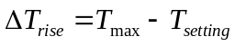 and the temperature fall is computed as 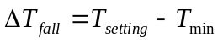where ΔT_{rise} is the temperature rise, ΔT_{fall} is the tempature fall, T_{max} is the maximum temperature, T_{min} is the minimum temperature, and T_{setting} is the temperature at which the bridge is constructed. The minimum, maximum, and setting temperatures are specified by the user input.

Support Settlement Load
QConBridge II models support settlement as differential settlement. That is, the structure is analyzed for the forces induced by the difference in settlement between two points of support. If all of the supports in the structure settle equally, it is assumed that load is not imparted onto the structure.

Slab Shrinkage
A slab shrinkage load is applied to Rolled and Built-Up Steel girder bridge product models. Slab shrinkage is modeled as equal and opposite concentrated moments applied at the beginning and ending of each segment in a span as shown in Figure 26.
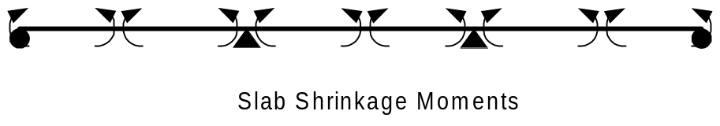
Figure 26 Slab Shrinkage Moments
The magnitude of the shrinkage moment is taken to be 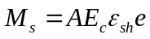 (See BDM 7.3.11), where
M_{s} | Moment due to slab shrinkage
A | Cross sectional area of the transformed slab.
E_{c} | Modulus of elasticity of slab concrete
ε_{sh} | Shrinkage strain
S | Moment arm
The cross sectional area of the transformed slab is based on long-term section properties (3n). Figure 27 shows the section geometry.
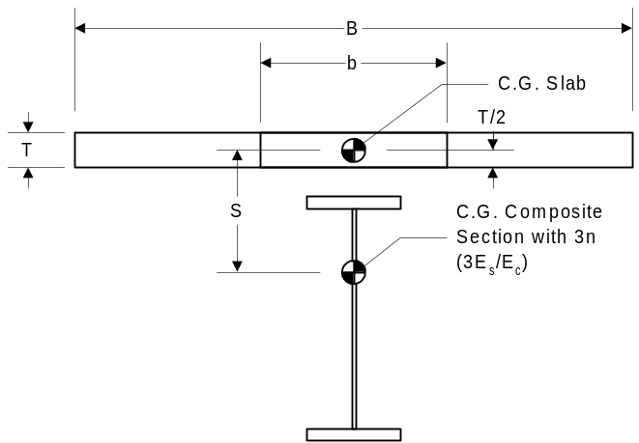
Figure 27 Section Geometry for Slab Shrinkage Moments

Special Analysis Considerations
The following sections detail special analysis considerations for LBAM's.

Dead Load Deflections
The basic LBAM computes deflections and rotations based on the section properties for the various analysis stages. In stages where the roadway deck is made composite, deflections and rotations are based on the effective flange width. Per LRFD 4.6.2.6.1 these deflections must be based on the full flange width of the girder line. To accomplish this, QConBridge II will compute dead load deflections and rotations for composite sections as 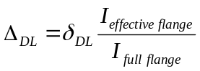where
Δ_{DL} | Dead load deflection or rotation
δ_{DL} | Dead load deflection or rotation computed from the LBAM
I_{effective flange} | Moment of inertia based on the effective flange width
I_{full flange} | Moment of inertia based on the full flange width

Live Load Deflections

For Evalution of Deflection Criteria
The deflections computed for the live load defined in LRFD 3.6.1.3.2 is used in evaluating the defection criteria specified in LRFD 2.5.2.6.2. To perform this analysis, QConBridge II analyzes the basic LBAM for the live load defined in 3.6.1.3.2 using the girder line section properties for the stage when the live load is applied to the model. For all of the bridge product models supported by this version of QConBridge, the live load is applied in a stage when the roadway deck is made composite with the girders. The deflections are computed using composite section properties based on the effective slab area.
The computed deflections must be adjusted to conform to the requirements of LRFD 2.5.2.6.2. The computed deflection is multiplied by the moment of inertia used in the LBAM, effectively normalizing the deflection to a moment of inertia of 1.0. The deflection is then multiplied by the number of design lanes to simulate all lanes loaded, is multiplied by the appropriate multiple presence factor, and divided by the moment of inertia for the entire bridge cross section. The live load deflection for LRFD 2.5.2.6.2 is taken to be 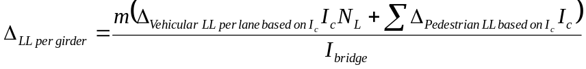 where
Δ_{LL per girder} | Live load deflection for LRFD 2.5.2.6.2 per girder line
m | Multiple presense factor
Δvehicular LL per lane based on Ic | Vehicular live load deflection per lane based on the moment of inertia used in the LBAM
Ic | Moment of inertia used in the LBAM
N_{L} | Number of design lanes
Δ_{pedestrian LL base on Ic} | Pedestrian live load deflections per sidewalk based on the moment of inertia used in the LBAM
I_{bridge} | Moment of inertia for the entire bridge cross section, including structurally continuous barries and sidewalks.

Deflections are computed for both the vehicular live load only and the vehicular live load plus pedestrian live load cases. Limit state combinations are not created for deflection.

For HL93 Live Load
The basic LBAM computes deflections and rotations based on the section properties for the various analysis stages. In stages where the roadway deck is made composite, deflections and rotations are based on the full flange width of the girder line (See LRFD 4.6.2.6.1). To accomplish this, QConBridge II will compute composite section properties based on the full flange width. Live load deflections and rotations will then be computed as 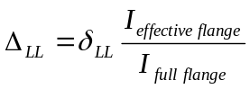where
Δ_{LL} | Live load deflection or rotation
δ_{LL} | Live load deflection or rotation computed from the LBAM
I_{effective flange} | Moment of inertia based on the effective flange width
I_{full flange} | Moment of inertia based on the full flange width
Distibution factors for this live load are defined in 5.6

Calculation of Rotations
To facilitate the design and analysis of bridge bearings, QConBridge II will compute some basic rotations at bearing locations. Rotations will be computed for all Load Groups and Load Cases. Rotations are not computed for Limit States.. Live load rotations will not be computed for the special live loading for deflection criteria.

Analysis Results
After the LBAM is generated from the product model, the problem being solved by QConBridge II becomes the same as for Analysis Model Projects. This section describes how QConBridge II takes the raw analysis results from the LBAM and combines them into Load Case and Limit State results.

The Basic Process
Figure 28 illustrates the basic process for analyzing a LBAM and computing Load Case and Limit State Results. Note that much detail is omitted. This detail will be covered throughout Section 6.5.
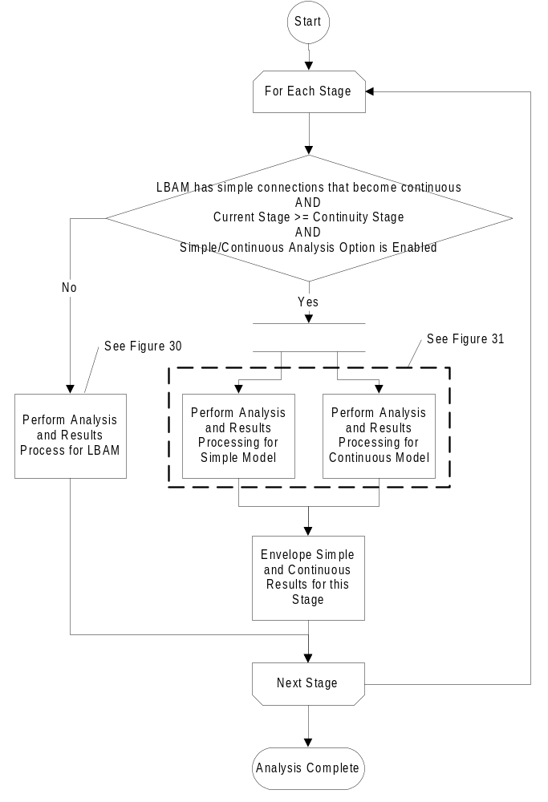
Figure 28 Basic LBAM Analysis Process
Every rectangle in Figure 29 through Figure 32 represent Load Case and Limit State Results QConBridge II computes.

Analysis and Results Processing
For the basic procedure described above, the majority of the work to be done is the analysis is results processing. Analysis and results processing is seen in more detail in Figure 29.
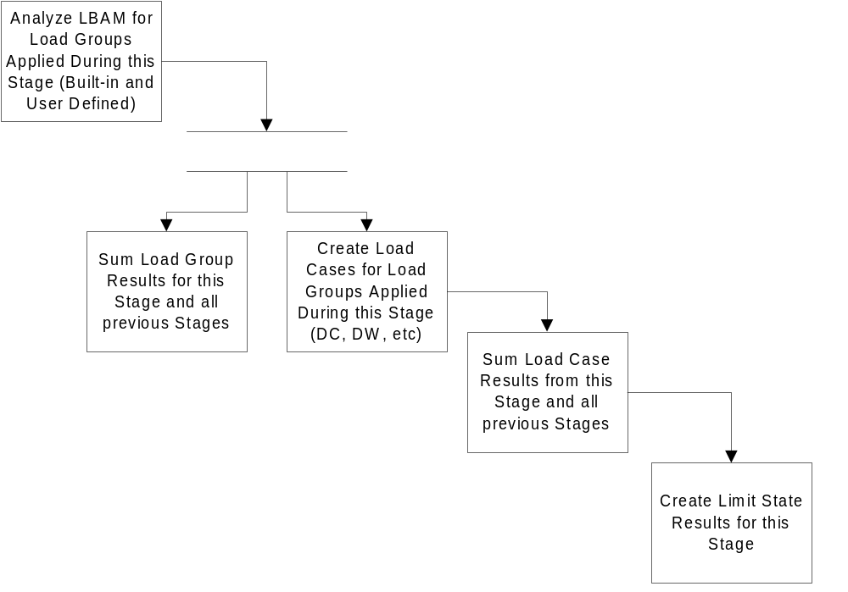
Figure 29 Analysis and Results Processing
The LBAM loading consists of named groups of loads (i.e. Group: Self-weight - consists of linear loads, concentrated loads, and concentrated moments) which represent the loads applied to the structure during a given stage. The LBAM for each stage is used to analyze the structure's response to these loads and determines moments, shears, and displacements at all points of interest. The analysis also computes reactions and rotations at support locations.
For this stage, these Load Group results are then added together to form Load Case results (i.e. Load Case: DC - sum of Load Group: Self-Weight, Load Group: Slab Weight, and Load Group: Diaphragm Weight).
The total response of a structure at any stage is the sum of the response of all previous stages. QConBridge II adds the Load Group responses and the Load Case responses for all previous stages to the current stage.
Finally, the total Load Case responses for this stage are combined into Limit State results. For all stages, except the final stage, the following Limit State results are computed:
- Strength I (Yields the same results as Strength III and Strength V)
- Strength IV
- Service I
For the final stage, the following Limit State results are computed:
- Strength I
- Strength II (using Permit and Special Live Loads)
- Strength III (If WA, WS, FR, TU, CR, SH, TG, and SE load cases are empty, this Limit State will not control over Strength I and need not be reported to the user)
- Strength IV
- Strength V (If WA, WS, WL, FR, TU, CR, SH, TG, and SE load cases are empty, this Limit State will not control over Strength I and need not be reported to the user)
- Extreme Event I (If EQ load case is empty, this Limit State will not control over Strength I and need not be reported to the user)
- Extreme Event II (If IC, CT, and CV load cases are empty, this Limit State will not control over Strength I and need not be reported to the user)
- Service I
- Service IA (if LBAM represents a prestressed girder bridge product model - LRFD 5.9.4.2.1 - one-half dead load case)
- Service II (if LBAM represents a steel bridge product model)
- Service III (if LBAM represents a prestressed girder bridge product model)
- Fatigue
- User Defined Limit States (using HL93 Live Load, Permit Live Load or Special Live Load)

Enveloping Simple/Continuous Results
When the Envelope Simple/Continuous Results analysis option is enabled, and the LBAM uses simple support connections that are made continuous, the Analysis and Results Processing becomes a bit more complex than illustrated in Figure 29. For the Continuity Stage and each stage thereafter, QConBridge II maintains two LBAMs, one for simple span analysis and one for continuous span analysis. For each model, QConBridge II processes the results as shown in Figure 29. Then, the program envelops the results, creating the controlling cases for this stage. This is shown in Figure 30.
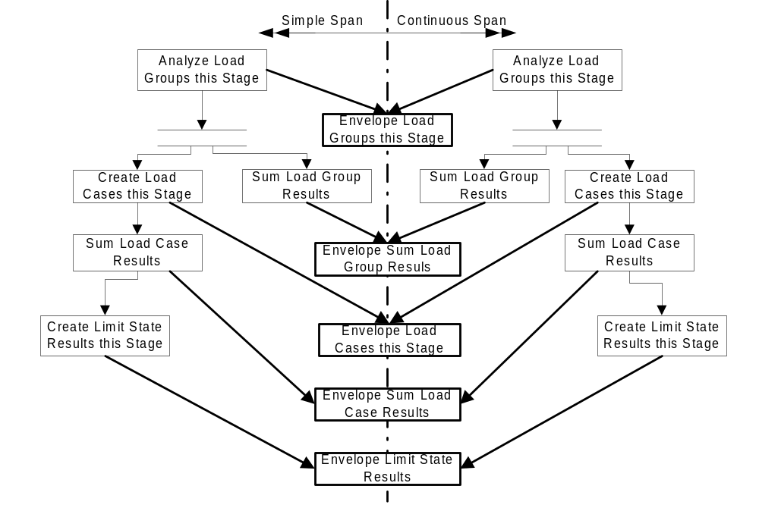
Figure 30 Analysis and Results Processing for Simple/Continuous Envelopes

Load Cases and Limit States involving Live Load
Live loads differ from other load cases in that they consist of not a single load, but of a combination of loading situations (Design Tandem + Lane, Design Truck + Lane, etc.), rules for applying the load to the structure, and which force effects are attributed to those loading situations (negative moment between points of contraflexure and reactions at interior piers). Live load cases also produce minimum and maximum results (envelopes).
Figure 31 and Figure 32 illustrate the myriad of Live Load Cases and Limit State combinations that QConBridge II must produce. For each point of interest in the LBAM, QConBridge II determines the extreme Limit State result for each force effect (moment, shear, etc.) considering the various combinations of Load Cases that make up the Limit State. For the combination of Load Cases that cause an extreme Limit State result at a point of interest, QConBridge II computes the corresponding Limit State results for all points of interest in the LBAM, for all force effects. For example, if the maximum moment at the base of Pier 2 for the Strength V Limit State occurs when the Design Truck with its rear axle at the minimum spacing is positioned at the center of Span 1 and the Design Lane Load occupies all of Span 1, the Breaking Force is applied, and a uniform Temperature Drop is applied, then QConBridge II will compute the Strength V Limit State Response for all points of interest in the LBAM for corresponding shear, reaction, and deflection. This scenario is carried out for every Limit State at every point of interest, for every force effect.
If QConBridge II envelopes simple span and continuous span results, as described in Section 6.5.1.2, the Load Cases and Limit States presented in Figure 31 and Figure 32 are created for the simple and continuous cases and enveloped as illustrated in Figure 30.
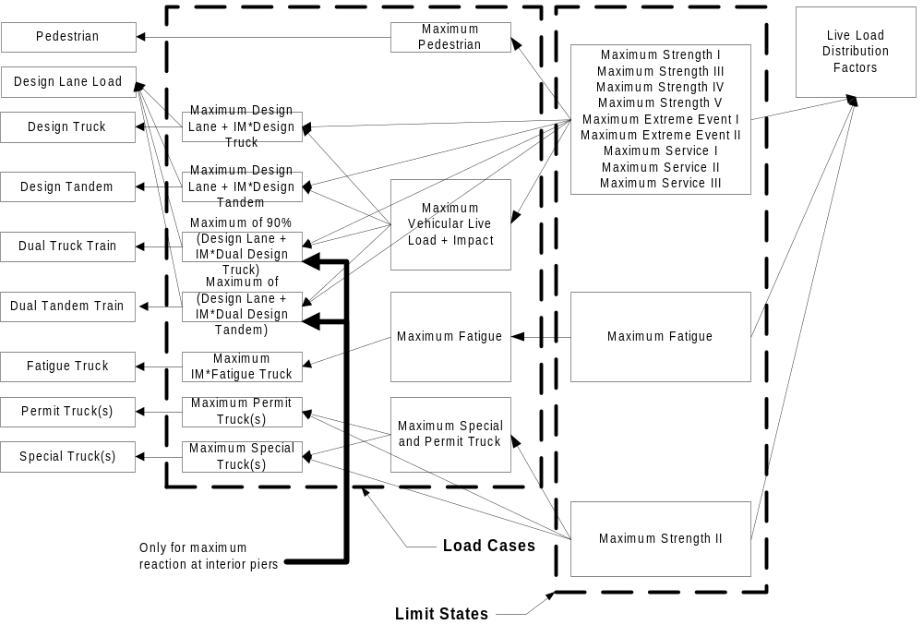
Figure 31 Maximum Limit States with Live Load
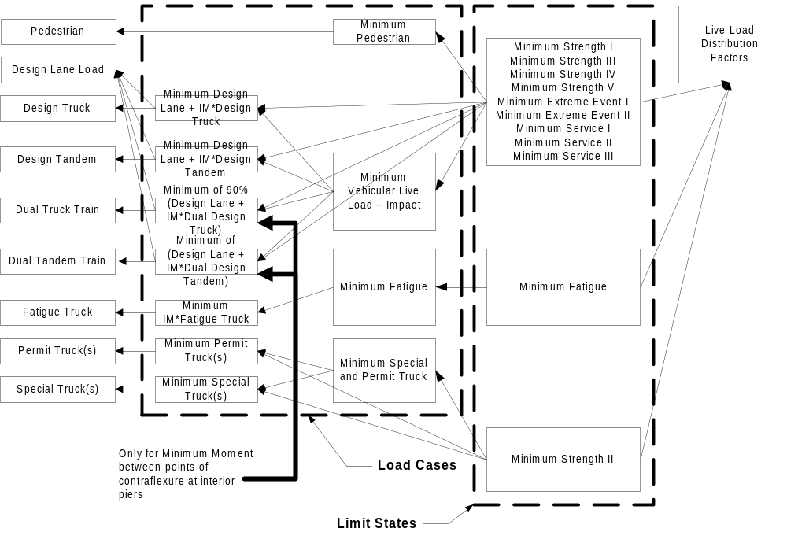
Figure 32 Minimum Limit States with Live Load

Computing Analysis Results

Load Factors
LRFD Table 3.4.1-1 presents single values for the load factors for transient loads. QConBridge II recognizes that these are maximum load factors. For transient loads, the case of the load not being present must be considered when determining extreme force effects. QConBridge II considers a minimum load factor of 0.00 for transient loads when computing Limit State Combinations.

Load Factors for TU, CR, and SH Load Cases
Per LRFD 3.4.1 the smaller of the Load Factors given for the TU, CR, and SH Load Cases in LRFD Table 3.4.1-1 are used for computing all force effects except deflections.

Load Modifiers
The load modifiers (η factors) described in LRFD 1.3.2.1 are to be considered on a per component basis. For QConBridge II, components are considered to be superstructure components and substructure components. That is, one set of load modifiers is input for the entire superstructure, and one set of load modifiers is input for each pier and abutment.

Special Notes
For LBAM's where permit and/or special live load is considered and the Strength II combinations are reported, QConBridge II outputs the following notice taken from LRFD C4.6.2.2.1.
In Strength Load Combination II, applying a distribution factor procedure to a loading involving a heavy permit load can be overly conservative unless lane-by-lane distribution factors are available. Use of a refined method of analysis will circumvent this situation.

Load Case Dependencies
Certain Load Cases logically depend upon the existence of other Load Cases. For example, force effects due to Wind on Live Load cannot occur if Live Load is not present. With transient loads, the possibility that a load is not present (γ = 0) must always be considered.
While QConBridge II does not compute loads for Braking, Centrifugal Force, Wind, Stream Flow, Earthquakes, etc, the software does provide an opportunity for the user to directly input loads to simulate these Load Cases. QConBridge II considers the logical dependency between load cases when performing Limit State combinations. Figure 33 shows the logical dependency between the LRFD Load Cases. The force effects of a Load Case are not included in a Limit State Combination if the Load Case(s) it depends on is not applicable to the Limit State.
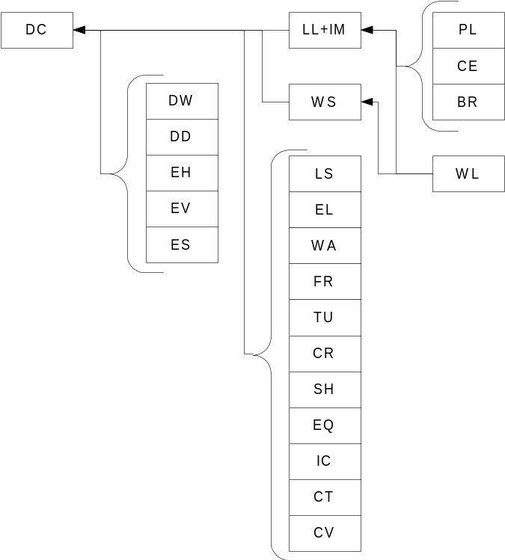
Figure 33 Load Case Dependencies

Distribution of Live Load to Girder Lines
In the LBAM's, all load cases are on a per girder line bases except live load. Vehicular live load and impact are on a per design lane bases. Pedestrian live load is on a per sidewalk basis. To form the Limit State combinations, the live loads must be distributed to a girder line. This is accomplished through the use of distribution factors.
The general Limit State formulation is where
Q | Limit State Force Effect
η_{i} | Load Modifier
γ_{i} | Load Factor
Q_{i} | Load Case Force Effect
g | Live Load Distribution Factor, which is taken to be the maximum of one loaded lane and two or more loaded lanes.
f_{ADTT} | Reduction factor for low ADTT.  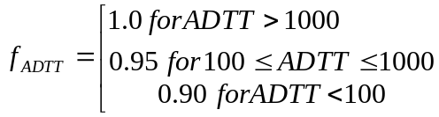  See LRFD C3.6.1.1.2
η_{LL+IM} | Load Modifier for Live Load + Impact
γ_{LL+IM} | Load Factor for Live Load + Impact
Q_{LL+IM} | Force Effect for Live Load + Impact
g_{PL} | Distribution Factor for Pedestrian Load (Scales a full sidewalk of Pedestrian Load to a girder line of pedestrian load).
η_{PL} | Load Modifier for Pedestrian Live Load
γ_{PL} | Load Factor for Pedestrian Live Load
Q_{PL} | Cumulative Force Effect for Pedestrian Live Load on both the Left and Right Sidewalks.

Deflections
QConBridge II computes deflections for the various Limit States due to the HL93 Live Load model and User Defined Live Loads. This section describes special considerations that are made when computing limit state deflections.

Load Factors for TU, CR, and SH Load Cases
Per LRFD 3.4.1 the larger of the Load Factors given for the TU, CR, and SH Load Cases in LRFD Table 3.4.1-1 are used for computing deflections.

Basis for Measurement
QConBridge II computes force effects for differential settlement between piers and abutments. However, the input for settlement is absolute measurement. That is, the actual settlement of a support is input and QConBridge II determines the differential settlement. The deflections computed by QConBridge II can be reported based on differential settlement or overall settlement. The basis for Limit State Deflections computed by QConBridge II is shown in Figure 34.
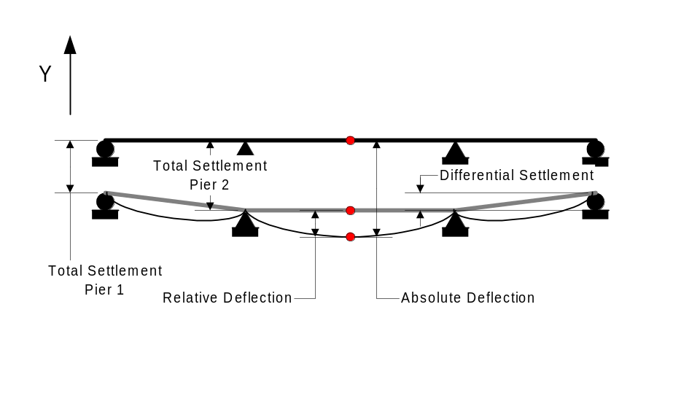
Figure 34 Basis for computing Limit State Deflections

Reactions
QConBridge II computes and reports reactions for abutments and piers.

Limit State Combinations for Reactions
Two sets of limit state reactions are reported for all piers and abutments. One set of reactions is for foundation elements above the ground surface and one is for the elements below the ground surface. For the foundation elements below the ground surface, the dynamic load allowance (impact) factor is taken to be 0% (See LRFD 3.6.2.1).

Zero Height Abutments and Piers
For zero-height abutments and piers, QConBridge II computes a vertical reaction. Reactions for all load groups, load cases, and limit states are reported on a per girder line basis. Vehicular and Pedestrian Live Load Reactions are reported on a per lane basis.

Fixed Height Abutments
For fixed-height abutments, QConBridge II computes vertical, horizontal, and moment reactions. Reactions for all load groups, load cases, and limit states are reported on a per girder line basis. Vehicular and Pedestrian Live Load Reactions are also reported on a per lane basis.

Fixed Height Piers
For fixed-height piers, QConBridge II computes a vertical reaction at the top of the column and vertical, horizontal, and moment reactions at the bottom of the column. The top of column vertical reaction is transferred into TBAM models at the bearing locations.
Reactions for all load groups, load cases, and limit states are reported on a per girder line basis. Vehicular and Pedestrian Live Load Reactions are also reported on a per design lane basis.

Deflections for Evaluation of LRFD 2.5.2.6.2
QConBridge II computes live load deflections for evaluation of LRFD 2.5.2.6.2 as specified in Section 6.4.2.1. These deflections are computed at all Points of Interest in the superstructure elements of the LBAM. These deflections are not Limit States. Deflections for vehicular live load only and vehicular live load plus pedestrian loads are computed and reported as different deflection criteria may apply.

Pedestrian Only Bridges
For Pedestrian Only Bridges, QConBridge II computes the same Limit States as for bridges with vehicular live load, except the intermediate Limit States relating to vehicular live load are omitted. The special deflection analysis for LRFD 2.5.2.6.2 is performed for Pedestrian Only Bridges.

Transverse Bridge Analysis Models
QConBridge II will perform a transverse dead load and live load analysis if a 3D pier structure has been defined. This section describes how the information from the product model is used to generate a TBAM.

Model Topology
This section describes how the model geometry is generated for the various types of pier product models supported by QConBridge II.

Cap Beam Modeling
The model of the cap beam is similar for all pier types supported by the program. Figure 35 shows the basic geometry of the cap beam elements along the rectangular cap beam. Cap beam elements are positioned at the centroid of the cap beam section at the location of each column. The cap beam elements are connected to the top of the column elements and have full connectivity with the column elements. Cap overhangs are projected along the same geometry as the cap beam of the exterior bays of the bent. For single column piers, hammerhead piers, and zero-height idealized piers, the cap beam is taken to be horizontal. Non-prismatic caps are modeled with a series of prismatic segments. Segment boundaries will occur at the face of each column and where ever the depth of the cross section is more than 10% different than the depth of the adjacent segment.
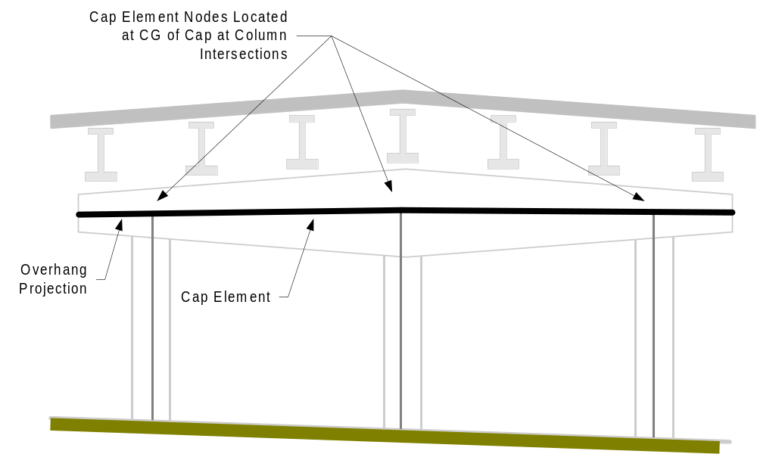
Figure 35 Structural Modeling of Cap Beam

2D Zero-Height Piers
A TBAM is not created for 2D Zero-Height Piers.

3D Zero-Height Piers
The product model for zero-height idealized pier defines support locations that represent columns or other supporting elements for a cap beam. A 3D Zero-Height Idealized Pier is modeled as a horizontal cap beam on pinned supports as shown in Figure 36.
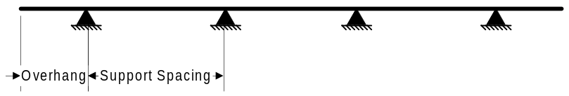
Figure 36 TBAM for a 3D Zero Height Idealized Pier

2D Fixed Height Piers
A TBAM is not created for 2D Fixed-Height Piers.

3D Fixed Height Piers
Figure 37 shows how fixed height piers are modeled for the transverse analysis. The bent frame is made up of n equally spaced columns. The cap beam extends beyond the exterior bays of the bent by the overhang distance. The columns are assumed to be the same height and as such, the cap beam is modeled as horizontal. The bases of the columns are fixed. The stiffness of each column is equal to 1/n times the stiffness defined in the product model for the pier.
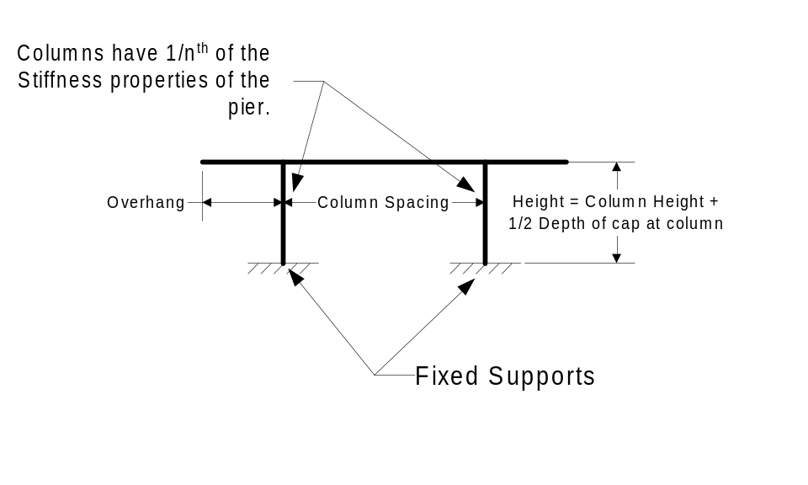
Figure 37 Analysis Modeling of Fixed Height 3D Piers

Full Product Model Piers
The typical geometry for a full product model pier is shown in Figure 38. The column heights in the analysis model are equal to the column heights in the product model plus the distance from the bottom of the cap beam to its centroid.
Non-prismatic columns are modeled using a series of prismatic segments starting from the bottom of the column and working upwards.
The bottoms of the column elements are fixed at the bottom and have full continuity with the cap beam elements at the top.
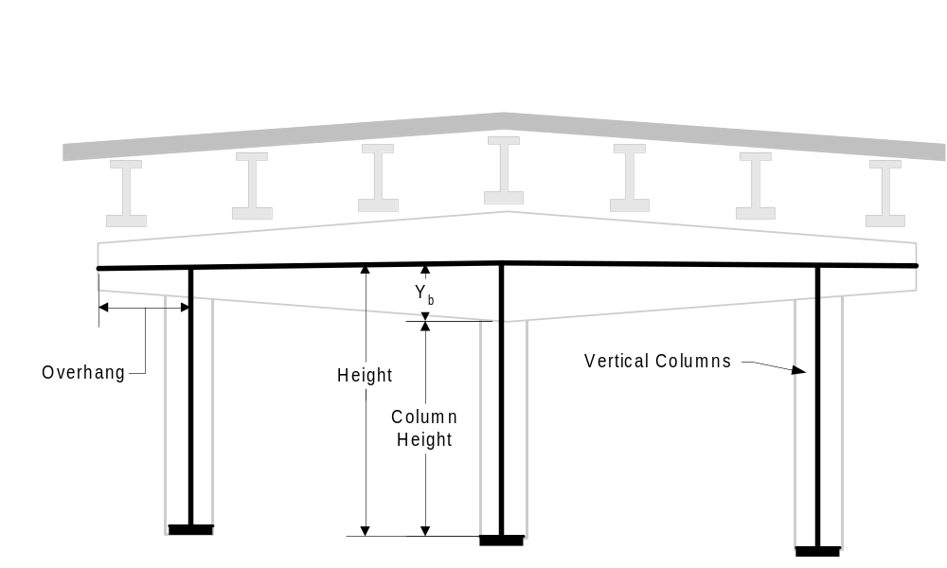
Figure 38 TBAM for Multicolumn and Hammerhead Piers
Column heights are computed as described in Section 6.1.2.2.3.

Loads
The loads imparted on a pier (as far as this version of QConBridge II is concerned) come from two different sources, the pier itself and loads from the superstructure. This section will describe how these loads are modeled in TBAMs.

Adjustments for Skew
For piers that are skewed with respect to the alignment, the transverse spacing of the load from the superstructure must be adjusted for skew.

Pier Loads
The loads described in this section are load applied directly to the pier model as opposed to loads that are transferred to the pier model from the superstructure.

Pier Self Weight
Self-weight of pier cap beam and columns are calculated as 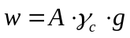 where,
w | weight per unit length of the column or cap beam segment
A | cross sectional area of the column or cap beam segment
γ_{c} | density of the pier concrete
g | gravitational acceleration.

Other Loads
Some other loads that would logically fall into this section are seismic, wind, and stream flow. However, this version of QConBridge II does not support these loading conditions. This is only mentioned so as to help distinguish loads applied directly to the pier from those transferred to the pier from the superstructure.

Superstructure Loads
This section describes the loads that are transferred to the pier from the superstructure. These loads come in the form of reactions taken from the girder line LBAM's.

Girder Self Weight
Self-weight of structural girder calculated using the girder area and girder material’s weight density. Girder reactions are applied to cap beam at bearing locations.

Slab Self Weight
Slab self weight includes the tributary self-weight of slab including haunch, sacrificial wearing surface, and overhang, if applicable. Girder reactions are applied to cap beam at bearing locations.
The effects of parabolic haunch depth due to camber are accounted for.

Intermediate Diaphragms
Applies tributary weight of Intermediate Diaphragms to girders. Girder reactions are applied to cap beam at bearing locations.

End Diaphragms
For connections where the weight of the diaphragm is carried by the girder, the weight of the end diaphragm is applied at bearing locations based on a tributary distribution of the weight to the girder lines. For connections where the weight of the diaphragm is applied directly tot he support element, the total weight of the diaphragm is distributed over the cap beam and applied as a uniform load.

Traffic Barrier
This load is derived from a uniform load based on the weight of the Traffic Barrier. If the load in the longitudinal model is distributed to all girder lines, then the girder reactions are applied to all points of bearing. If the load in the longitudinal model is distributed to n exterior girder lines, then only the bearing locations associated with those girder lines are loaded.

Median Barrier
This load is derived from a uniform load based on the weight of the Median Barrier (if it exists). If the load in the longitudinal model is distributed to all girder lines, then the girder reactions are applied to all points of bearing. If the load in the longitudinal model is distributed to n adjacent girder lines, then only the bearing locations associated with those girder lines are loaded.

Overlay
This load is derived from a uniform load based on the depth of the overlay, the overlay material properties, and the curb-to-curb width of the roadway surface. Regardless if this load is uniformly distributed amongst all girder lines or is applied to each girder line based on its tributary area, the girder line reactions are applied to the cap beam at the bearing locations.

Sidewalk
This load is derived from a uniform load based on the weight of the Sidewalk (if it exists). If the load in the longitudinal model is distributed to all girder lines, then the girder reactions are applied to all points of bearing. If the load in the longitudinal model is distributed to n exterior girder lines, then only the bearing locations associated with those girder lines are loaded.

Live Loads
The longitudinal analysis models compute live load reactions on the bases of one loaded lane. These reactions must be imparted onto the TBAM for all permutations of loaded lanes and design lane configurations. The sections that follow describe:
- how the live load reactions are modeled as loads in a TBAM
- where the loads are applied to the TBAM (location of the design lanes and the location of a within a design lane)
- how the loads are transferred from the superstructure to the substructure models

Modeling of Live Load Reactions
The live load reactions computed from the LBAM's for each girder line are simply a vertical force per design lane. For the vehicular live load, there is a truck load portion and lane load portion. For pedestrian live load, there is only a lane load portion. The method for representing the truck load and lane load portions of the live load reactions are described below.
Potentially, each girder line and its associated LBAM is a different length, resulting in different live load reactions per lane across the width of the structure. QConBridge II simplifies this situation by using the maximum live load reaction for all girder lines.
When the envelope simple/continuous option is enabled, the maximum of the simple span and continuous span reaction is used, but not both.

Live Load Reactions applied to the TBAM
For the HL93 Live Load model, only the lane/truck combination that creates the maximum reaction are applied to the live load transfer model. QConBridge II does not analyze the TBAM for all the elements of HL93.
For Special and Permit Trucks, only the controlling cases are applied to the TBAM.

Truck Load reactions
QConBridge II has two methods of representing truck load reactions in TBAM's as illustrated in Figure 39.
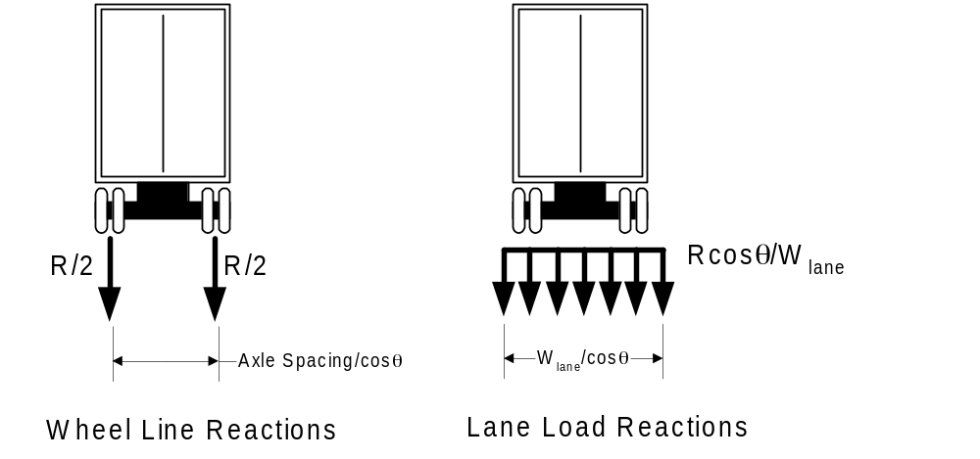
Figure 39 Representation of Vehicular Live Load Reactions in TBAM's

Wheel Line Reactions
For this option, the total truck load reaction per lane is divided by two to compute the reaction per wheel line. The wheel line reactions are positioned in a design lane spaced in accordance with LRFD 3.6.1.2 (1800 mm apart - not closer than 600 mm from the lane edge). The transverse wheel line spacing must be adjusted for skew.

Lane Reactions
For this option, the total truck load reaction per lane is uniformly distributed over the same width as the lane load as specified in LRFD 3.6.1.2.4, adjusted for skew.

Lane Load Reactions
The lane load portion of vehicular live load reaction is uniformly distributed over the distance specified in LRFD 3.6.1.2.4 (3000 mm), adjusted for skew.

Pedestrian Load Reactions
Pedestrian load reactions are distributed over the width of the sidewalk, adjusted for skew.

Design Lane Configurations
The width of a design lane is specified in LRFD 3.6.1.1.1. In general, a whole number of design lanes does not exactly fill the curb-to-curb width of the bridge as seen in Figure 40. There is usually some excess space, denoted as W_{excess}. Because the design lanes must be positioned to cause the extreme force effects, the configuration of the design lanes must change for the various force effects in the structure. It is not practical to analyze a pier for every possible design lane configuration or to determine the optimum lane configuration for each force effect. QConBridge II positions the design lanes are shown in Figure 43.
Design lanes are always positioned curb to curb. QConBridge II ignores the presence of median barriers when determining design lane configurations.
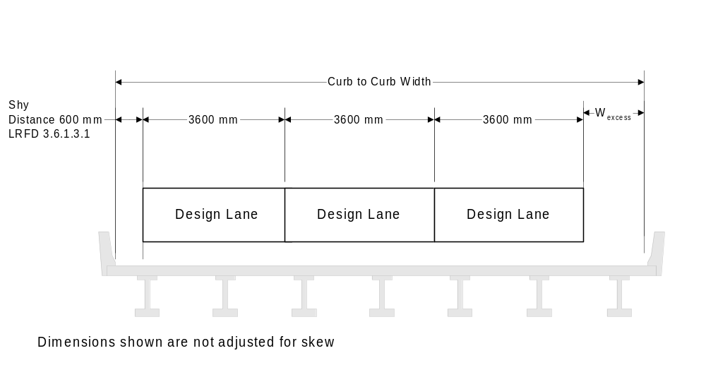
Figure 40 Lane Configurations
When sidewalks are present in the product model, and they have sufficient width to warrant loading per LRFD 3.6.1.6, QConBridge II models design lane configurations with and without the effect of the sidewalk. When the sidewalk is accounted for in the load transfer model, pedestrian live load is applied to the model. If the structure has sidewalks on each side, design lane configurations are considered for no sidewalks, one sidewalk on the left, one sidewalk on the right, and two sidewalks.
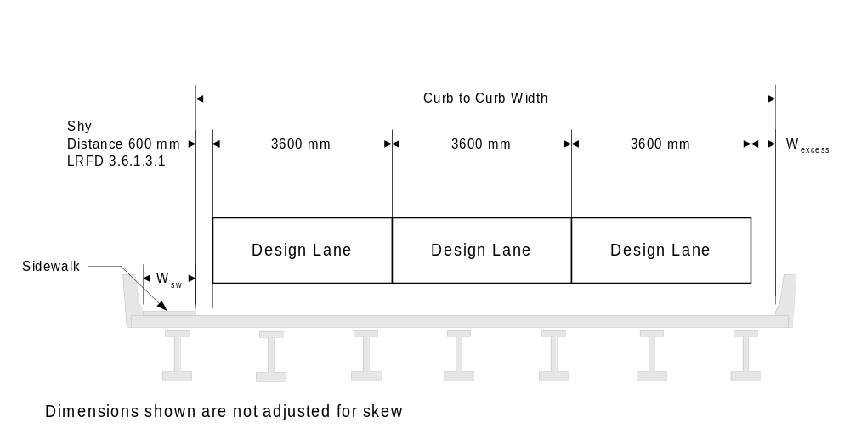
Figure 41 Design Lane Configuration with one sidewalk
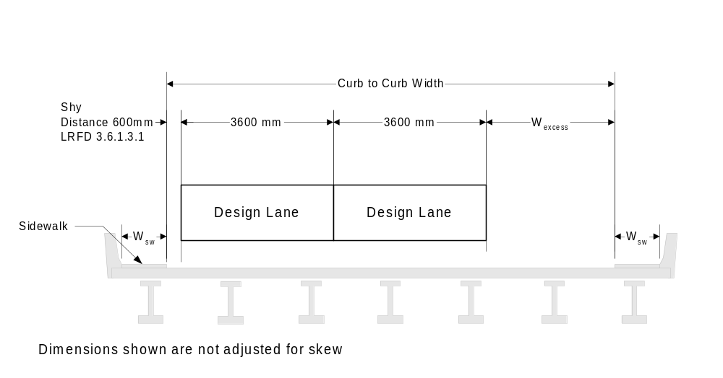
Figure 42 Design Lane Configuration with two sidewalks

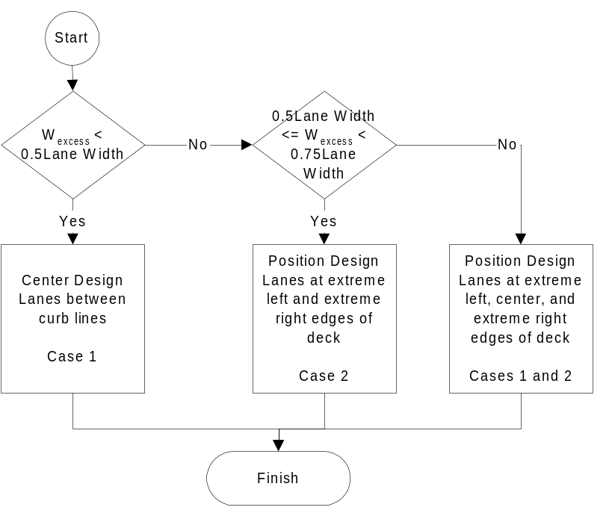
Figure 43 Design Lane Configuration for TBAM's

Location of Live Load Within a Design Lane
A lane of live load does not occupy the full width of a design lane. The design lane loads occupies 3000 mm of the 3600 mm design lane. Truck loads occupy 1800 mm of the design lane, and the wheel lines cannot be closer that 600 mm from the lane edge. The sections that follow describe how the live load reactions, applied to load transfer models, are positioned within the design lanes.

Case 1 - Design Lanes Centered Between Curb Lines
When the design lanes are centered between curb lines, the location of the live load within the design lane varies. For the leftmost design lane, the live load is positioned as far to the left as possible. For the rightmost design lane, the live load is positioned as far to the right as possible. The live load is positioned in the center of the center design lane (if there is an odd number of design lanes). The offset of the live load in all other design lanes is taken as a linear interpolation between the center and edge design lanes.

Case 2 - Design Lanes At Left or Right Curb Line
When the design lanes are positioned either at the left or right curb line, the live load is positioned as far to the left or right edge of the design lane as possible.

Permutations of Loaded Lanes
The TBAM must be loaded with the combination of lane loads that cause the extreme force effects. To facilitate this, QConBridge II applies various permutations of loaded design lanes to the analysis model. QConBridge II analyzes the TBAM for all possible combinations of loaded lanes. Figure 44 through Figure 46 show the various permutations of loaded lanes for a structure with two sidewalks. Per LRFD 3.6.1.1.2, sidewalks loaded with pedestrian load are considered to be equivalent to one loaded lane, except the case of pedestrian load only is not considered for vehicular bridges. The actual transverse placement of the design lanes is specified in Section 7.2.3.9.2.
Figure 44 shows the case when pedestrian load is not considered. Sidewalk dead load (and median barrier dead load if applicable) is still accounted for in this loading situation. In this configuration, the structure can accommodate three design lanes.
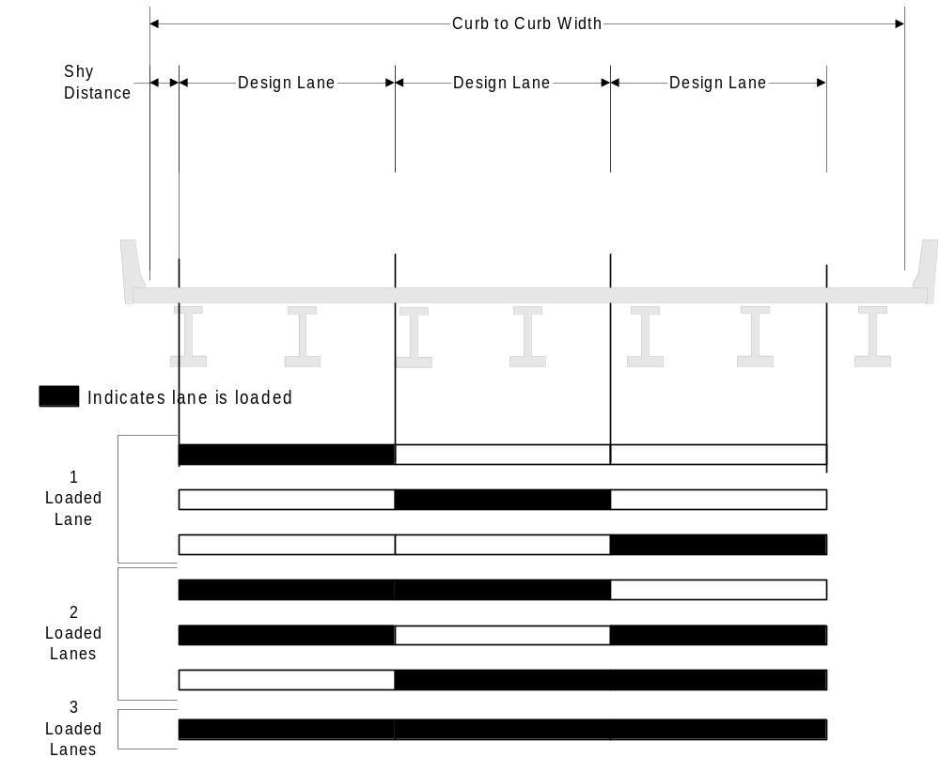
Figure 44 Permutations of Loaded Design Lanes for a 3 Lane Structure
Figure 45 shows the case when pedestrian load is considered to be only on one sidewalk. Load of a sidewalk on only one side of the bridge produces maximum magnitudes of certain force effects. Sidewalk dead load (and median barrier dead load if applicable) is still accounted for in this loading situation. In this configuration, the structure can still accommodate three design lanes.
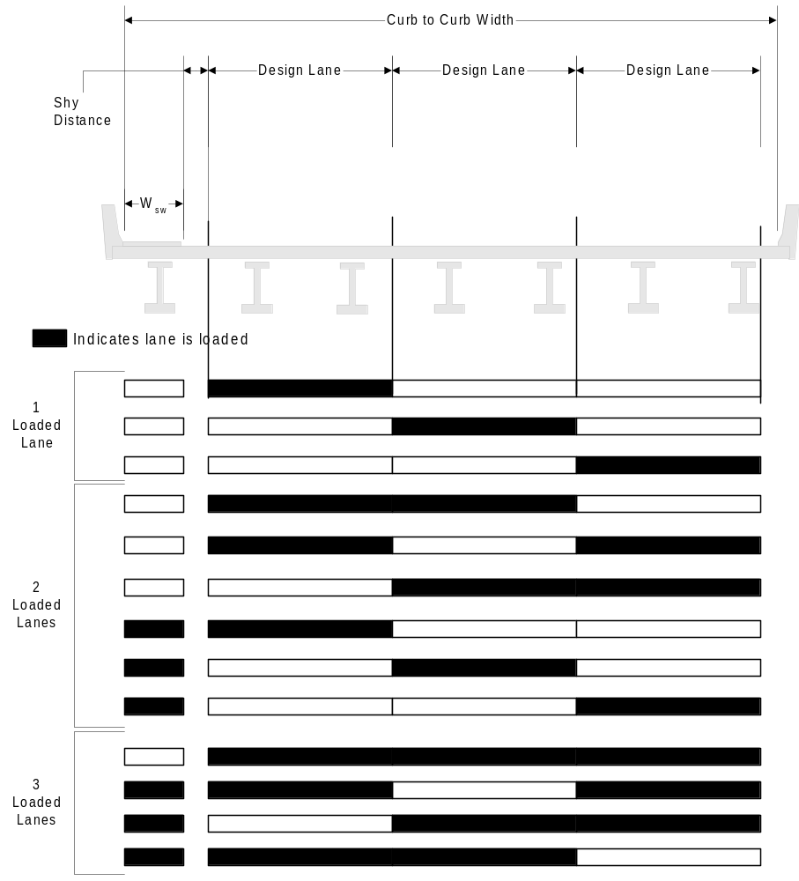
Figure 45 Permutations of Loaded Design Lanes for a 3 Lane Structure with a Sidewalk
Figure 46 shows the case when pedestrian load is considered to be on both sidewalks. In this configuration, the structure can accommodate two design lanes.
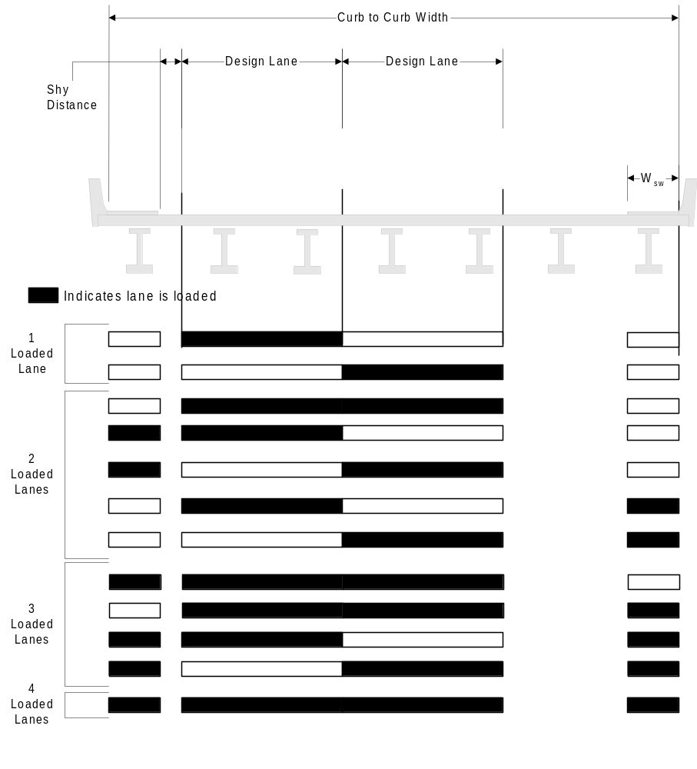
Figure 46 Permutations of Loaded Design Lanes for a 3 Lane Structure with two Sidewalks

Load Transfer Models
Live load reactions are distributed to the cap beam through a load transfer model. The two load transfer models support by QConBridge II are described below.

Rigid Links (Lever Rule)
For this transfer model, live load reactions are applied to a model of rigid links as shown in Figure 47. This is basically a lever rule distribution. Reaction points in the transfer model represent the bearing locations. The rigid beams are simple spans between girder lines. The exterior transfer beams have cantilever sections that represent the overhang of the bridge deck.
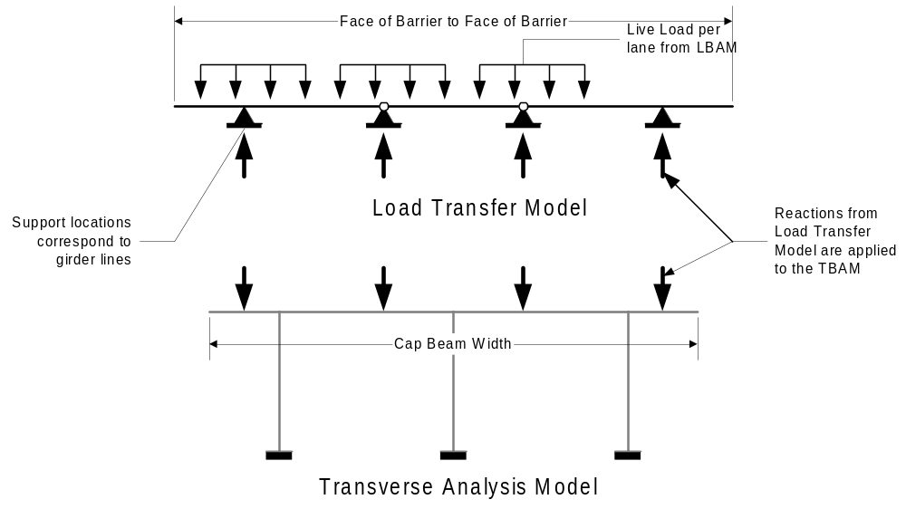
Figure 47 Rigid Links Load Transfer Model

Drop Through
For this transfer model, the live load reactions are applied directly to the cap beam elements of the transverse analysis model. This is shown in Figure 48. When the curb to curb width of the roadway exceeds the width of the cap beam, the load extending beyond the cap beam is applied to the end of the cap beam as a concentrated load and as an equivalent couple at the base of the exterior columns (for single columns piers, a concentrated moment is used). The loads shown below are for illustrative purposes. For actual modeling of the live load reactions as loads in the TBAM, see section 7.2.3.9.1. This transfer model is used in WSDOT's office practice, as described in BDM 9.1.1C.
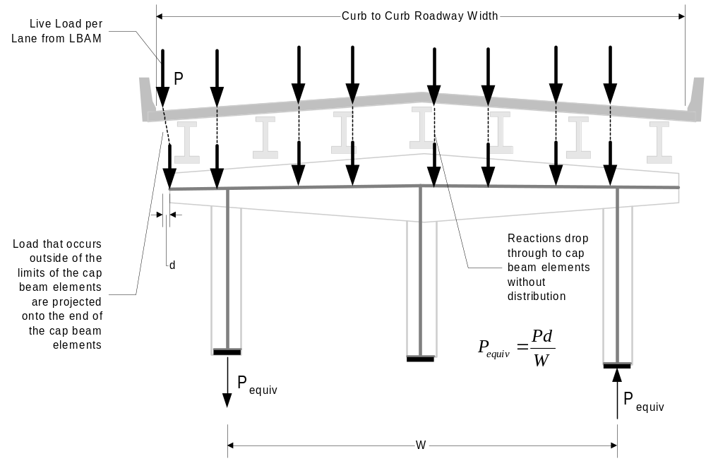
Figure 48 Drop-Through Load Transfer Model

Analysis Results
After the TBAM is generated from the product model, the problem being solved by QConBridge II becomes the same as for Analysis Model Projects or Transverse Only Analysis Model. This section describes how QConBridge II takes the raw analysis results from the TBAM and combines them into Load Case and Limit State results. The process that QConBridge II uses for TBAMs is very similar to the process for LBAMs, though somewhat less complex. TBAMs do not need to consider staging, the various components of the HL93 Live Load, or enveloping simple span and continuous structures.

The Basic Process
Figure 49 illustrates the basic process for analyzing a TBAM and computing Load Case and Limit State Results. The TBAM is loaded as described above. The live load is applied in various combinations to produce the minimum and maximum load cases.
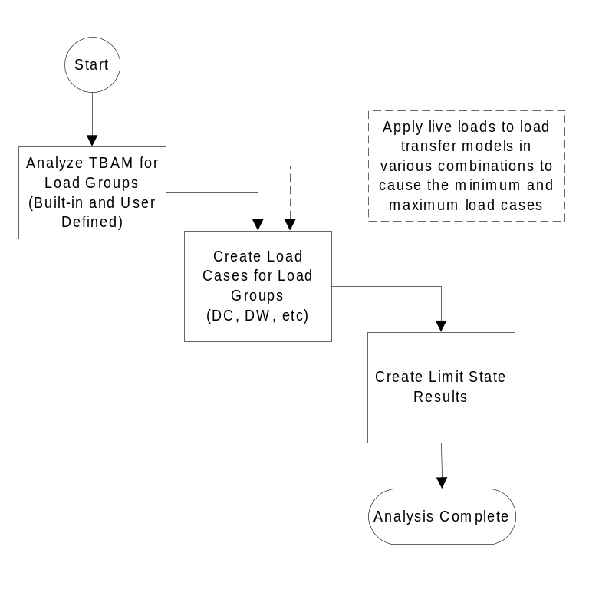
Figure 49 Basic TBAM Analysis Process
The total Load Case responses for the TBAM are combined into Limit State results. The following Limit State results are computed:
- Strength I
- Strength II (using Permit and Special Live Loads)
- Strength III (If WA, WS, FR, TU, CR, SH, TG, and SE load cases are empty, this Limit State will not control over Strength I and need not be reported to the user)
- Strength IV
- Strength V (If WA, WS, WL, FR, TU, CR, SH, TG, and SE load cases are empty, this Limit State will not control over Strength I and need not be reported to the user)
- Extreme Event I (If EQ load case is empty, this Limit State will not control over Strength I and need not be reported to the user)
- Extreme Event II (If IC, CT, and CV load cases are empty, this Limit State will not control over Strength I and need not be reported to the user)
- Service I
- Fatigue
- User Defined Limit States (using either/or HL93 Live Load or User Defined Live Load)

TBAM Results
For each of the Load Groups, Load Cases, and Limit States, QConBridge II will compute moments and shears in the cap beam and moments, shears, and axial each column. QConBridge II will also compute reactions at the base of columns. Limit State reactions will be computed for above ground and below ground components of the foundation. QConBridge II will report analysis results at all points of interest.

Total Pier Results (Combining LBAM Results with TBAM Results)
QConBridge II approximates the total structural response at a pier by factoring in the LBAM response. The total response is reported separately from the TBAM results so as to avoid confusion.
The total response at the base of the columns is reported in a coordinate system parallel to the plane of the TBAM. The reactions in the plane of the TBAM are reported per girder, per column, and for Vehicular and Pedestrian Live Load, per design lane. Figure 50 illustrates how QConBridge II transforms the LBAM reactions into the plane of the TBAM. Note that eccentricities due to bearing locations at the connections are not modeled. This means that torsion in the cap beam and moment in the columns due to eccentricity of the bearing line are not modeled.
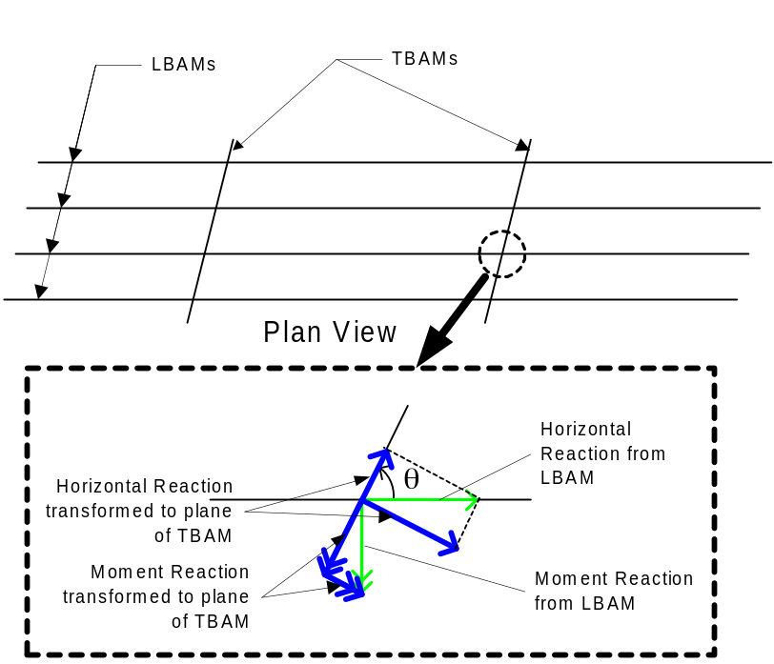
Figure 50 LBAM Reactions Transformed to plane of TBAM
QConBridge II will combine the transformed reactions from the LBAM with the TBAM reactions when reporting 3D pier reactions. The reactions from the TBAMs will be per column. The transformed LBAM reactions per column are computed as 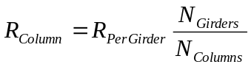where
R_{Per Column} | Per column reaction
R_{Per Girder} | Per girder line reaction
N_{Girders} | Number of Girders
N_{Columns} | Number of Columns

See Design Memorandum 03-2000 (Dated 4/18/2000)
1
Actually, all horizontal dimensions can be divided by cosθ. Only for the case of curve bridge with straight girders is cosθ not equal to 1.
Loading the sidewalk on only one side of the bridge is consistent with LFD 3.14.1.2.

