INSTRUCTIONS – PAGE 1
Only print those pages of the UFD actually used
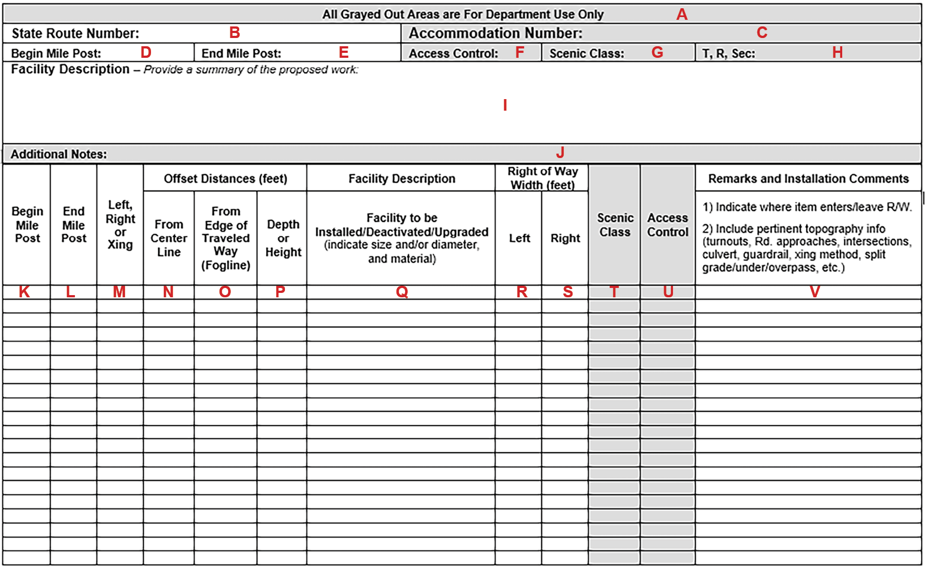

INSTRUCTIONS – PAGE 2
- All grayed out boxes are “For Dept. Use Only.” Items C, F, G, H, J, T, and U will be filled out by WSDOT.
- State Route Number.
- WSDOT will enter the Accommodation Number.
- The Beginning Milepost, rounded to nearest hundredth of a mile, of the proposed facility. For a visual location of the beginning milepost, use the website: http://www.snagmp.com/
- The Ending Milepost, rounded to nearest hundredth of a mile, of the proposed facility. For a visual location of the Ending milepost, use the website: http://www.snagmp.com/
- WSDOT will enter the overall Access Control.
- WSDOT will enter the overall Scenic Classification.
- WSDOT will enter the Township Range and Section (optional).
- Provide a short Summary of the proposed work below. The exact changes of the facilities beginning and end, as well as other specifics will be described on this form in other boxes. This box is for an overview and other information not described elsewhere.
- Additional Notes to be entered by WSDOT (optional).
- Begin Milepost: The beginning milepost for each row entry of the proposed facility. (Each new row is determined by change(s) in the alignment, size or capacity of the facility.)
- End Milepost: The ending milepost of each row entry of the proposed facility.
- Left, Right, Crossing: (Location of the facility with respect to the painted centerline of the highway looking toward increasing Milepost.) Varying mileposts depict a crossing at an angle. If the facility changes direction on one side of the ROW, this entry clarified this, as well as explaining where the facility leaves the ROW.
- Distance from the painted Centerline to the proposed facility.
- Distance from the edge Traveled Way or Fog Line to the facility.
- Depth, straight down, or height, from the lowest point of facility, to the finished grade.
- Detailed Facility Description or project. Be as complete as possible including changes in size, type or capacity of facility.
- Right of Way width, in feet, on the left side measured from the highway centerline alignment as depicted on the Right of Way sheets. Please contact the appropriate Region Utilities Office for ROW plan sheet(s).
- Right of Way width, in feet, on the right side measured from the highway centerline alignment as depicted on the Right of Way sheets. Please contact the appropriate Region Utilities Office for ROW plan sheet(s).
- Scenic Classification designation of the milepost limits of each row entry, to be entered by WSDOT.
- Access Control designation of affected section of highway for each row entry, to be entered by WSDOT.
- Enter Remarks to further describe the proposed facility for each row entry. Include crossroads, installation method, and location of bore pits. Indicate where the proposed facility enters or leaves Right of Way. Include pertinent topography info turnouts, road approaches, intersections, culvert, guardrail, crossing method, split grade(s), underpass, overpass, etc.
Please only print those pages of the UFD used.
All Grayed Out Areas are For Department Use Only
State Route Number: |  | Accommodation Number:
Begin Mile Post: | End Mile Post: | Access Control: | Scenic Class: | T, R, Sec:
Facility Description – Provide a summary of the proposed work:

Additional Notes:

Begin Mile Post | End Mile Post | Left, Right or Xing | Offset Distances (feet) |  |  | Facility Description | Right of Way Width (feet) |  | Scenic Class | Access Control | Remarks and Installation Comments
 |  |  | From Center Line | From Edge of Traveled Way (Fogline) | Depth or Height | Facility to be Installed/Deactivated/Upgraded (indicate size and/or diameter, and material) | Left | Right |  |  | 1) Indicate where item enters/leave R/W.  2) Include pertinent topography info (turnouts, Rd. approaches, intersections, culvert, guardrail, xing method, split grade/under/overpass, etc.)

