I-4 / 172nd Street Interchange Improvements
and
Douglas Road Realignment
Cost Risk Assessment

PREP MEETING: May 20, 2018
WORKSHOP DATES: June 7th and 8th, 2018
Draft Report: August 24, 2019
Final Report: September 14, 2019
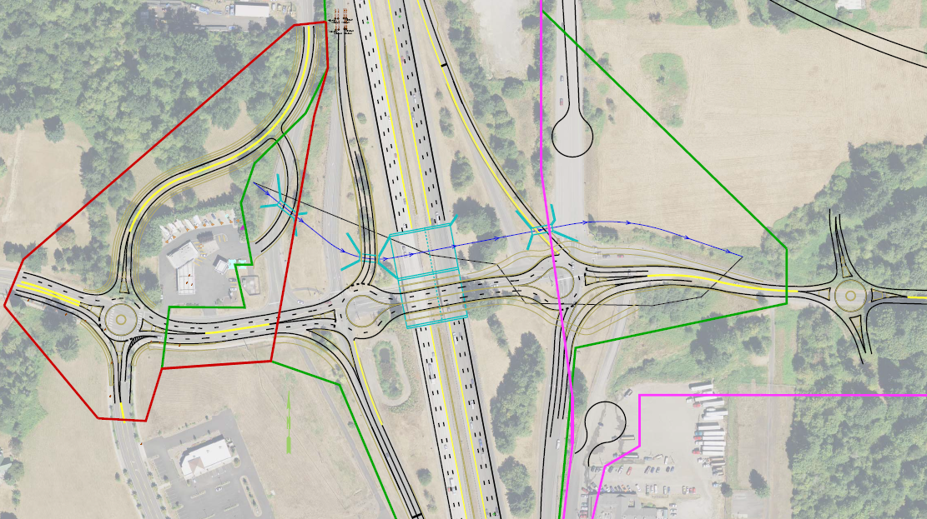

Project Need

Provide the necessary transportation infrastructure to support the Blues County Comprehensive Growth Management Plan at the I-4/172nd Street Interchange in the interchange vicinity, while minimizing impacts to I-4.

Maintain or improve circulation for Blues County Fairgrounds/Amphitheater events, emergency services/fire station complex/EOC. Provide traffic connectivity with circulating routes (12th/13th or Douglas). Provide bicycle and pedestrian connectivity consistent with local plans. Account for fish passage barrier culvert in project vicinity.

Project Description

Interchange improvements including roundabouts at the ramp terminals and local arterial connections, new bridges carrying I-4 traffic over 172nd Street, lengthening of northern ramps.

Legislative Intent (provide source and date)

Constructing interchange improvements to allow for commercial development in the area (TEIS – 6/10/18).

Project Engineer: Griffin Munchy | 360-605-1234  Project Manager: Horst Bugburger | 360-605-1555 desk / 360-222-6666 cell  Design Team Leader: Dat Dang Nguyen/Calliope Catterwall | 360-888-7777 desk / 360-555-1111 cell | Risk Lead: Walter Kensington  Risk Analyst: Pietro Mattaguise

Table of Contents

One-Pager: I-4 / 172nd St I/C Improvements
Executive Summary
1 Project Overview | 1-1
Background
Scoping
Corridor concept
Site characteristics, features and context
Schedule
Pre-Design details

2 Project Detail Report | 2-1
Project Flowchart
Project Vicinity Map
Workshop notes

3 Base Estimate Review | 3-1
Base Cost Estimate review notes
Basis of Estimate

Appendix A Attendance
Appendix B Base Cost Estimates – complete spreadsheets
Appendix C Risk model inputs
Base Estimate and Risk ID Sheets
Risk Breakdown Chart
Appendix D Risk model outputs
Current Year and Year of Expenditure Dollars
Risk Management Plan

PREP MEETING: May 30, 2019
WORKSHOP DATES: August 6th and 8th, 2018
Draft Report: August 24, 2018
Final Report: September 18, 2018

